|  |
| --- |
|  |
| **Annual Quality Analysis FY22**  *Working Together for A Better Tomorrow* |
| |  |  |  | | --- | --- | --- | |  |  |  | |

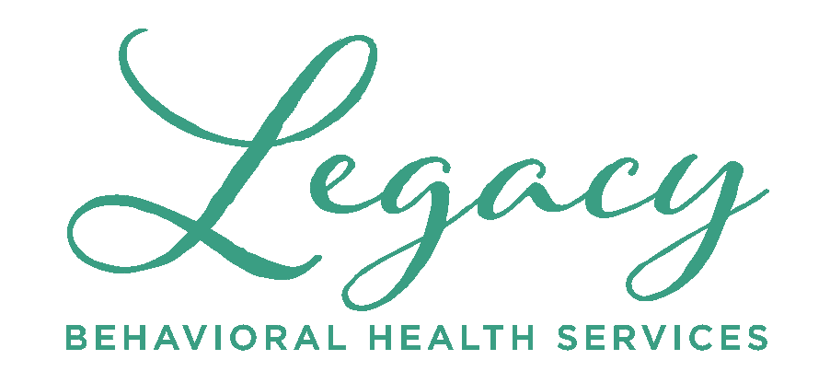

**Our Mission**

**To provide the highest quality behavioral health and developmental disabilities services to individuals, their families, and the community through prevention, intervention, treatment, and education.**

**Our Vision**

**All people are accorded respect, dignity, and opportunity to achieve their full potential free from stigma and prejudice.**

**Our Values**

**Collaboration ● Excellence ● Inclusiveness ● Integrity ● Respect**

**What’s Inside**

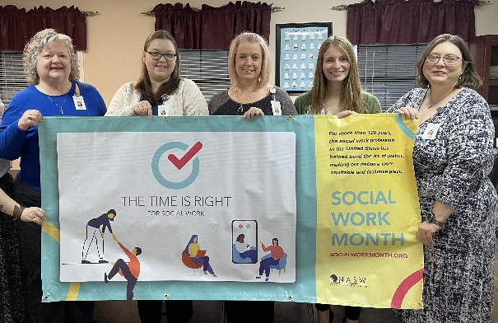**Page 3. Message from the CEO**

**Page 4. Community Impact Summary**

**Page 5. Satisfaction Survey Results**

**Page 7. LBHS Programs at Glance**

**Page 8. Financial Statement**

**Page 9. Organizational Business Functions**

**Page 18. BHCC**

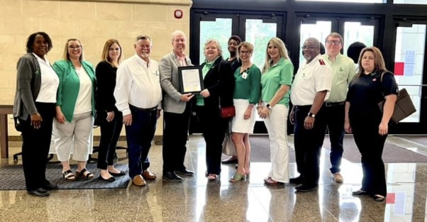**Page 26. OP Clinics**

**Page 36. ACT**

**Page 40. Supported Employment**

**Page 46. Peer Services**

**Page 48. IDD Services**

**Page 55. MAT/OBOT**

**Page 60. PATH Services**

**Page 65. Residential Services**

**Page 90. HIV EIS Program**

**Page 92. Executive Summary**

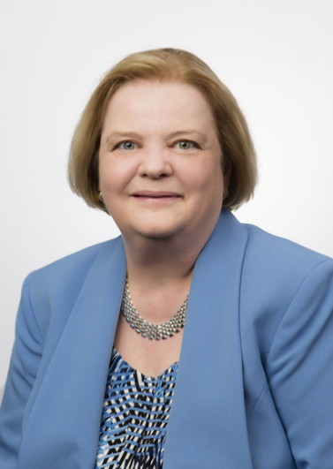**Message from the CEO**

**Pam Cartwright, FACHE**

I am pleased to present you with our Annual Quality Analysis for Fiscal Year 2022.

This past year has been challenging as we have continued to deal with the ongoing impact of the pandemic, which has included utilization of tele-health practices, adjusted work locations, and addressing staffing shortages. Our providers have persevered and stayed on focus by meeting the needs of the individuals and communities we serve, despite unprecedented labor shortages.

During FY22, we provided Behavioral Health and Intellectual and Developmental services to 7,759 individuals. In order to better serve our communities most vulnerable members, LBHS expanded housing, educational, clinical and community support services. Some of these accomplishments included:

* Implementation and expansion of a Medication-Assisted Treatment (MAT) program to treat opioid and alcohol addictions.
* Successfully obtaining the DBHDD contract for the Housing Support/Permanent Housing, Georgia Housing Voucher Program. The program provides supportive housing to individuals who are experiencing homeless who have been diagnosed with a Severe and Persistent Mental Illness along with other required criteria. The service area covers 24 counties located in South and Southwest Georgia.
* Expansion of community mental health educational offerings to educators, law enforcement, and other community members.
* Implementation of DBHDD grant funded Jail In-Reach Program to individuals who are incarcerated with mental health diagnosis with linkage to mental health services and community resources with a goal to prevent reincarceration.
* Obtainment of a DBHDD Grant for establishment of a Co-Responder Program which partners a therapist and a police officer, to respond to calls involving individuals with mental health issues.

We don’t know what challenges lie ahead in Fiscal Year 2023. What we do know is that our staff will be ready to meet them by providing hope and compassionate care to those most in need. We thank each of our staff for their service and we thank the persons served, the South Georgia Community Service Board, our partners, and the communities, for allowing us to do this meaningful and rewarding work.

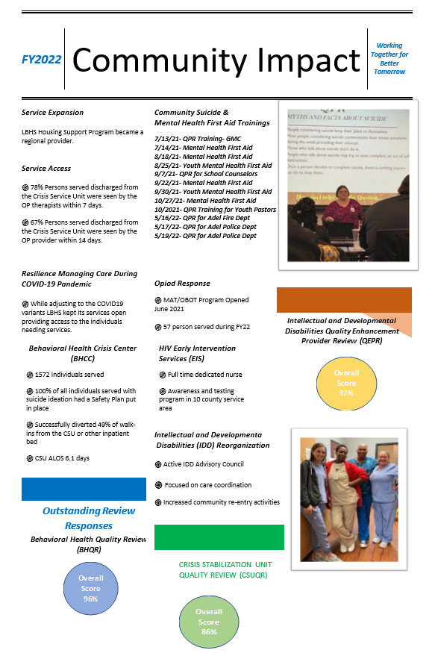

**Outcomes from Satisfaction Surveys**

**Outcomes from Satisfaction Surveys**

GADDSS

Do you feel safe at home?

100% answered YES

GADDSS

Are you happy with the staff and the services you receive here?

100% answered YES

GADDSS

Do people treat you with respect?

100% answered YES

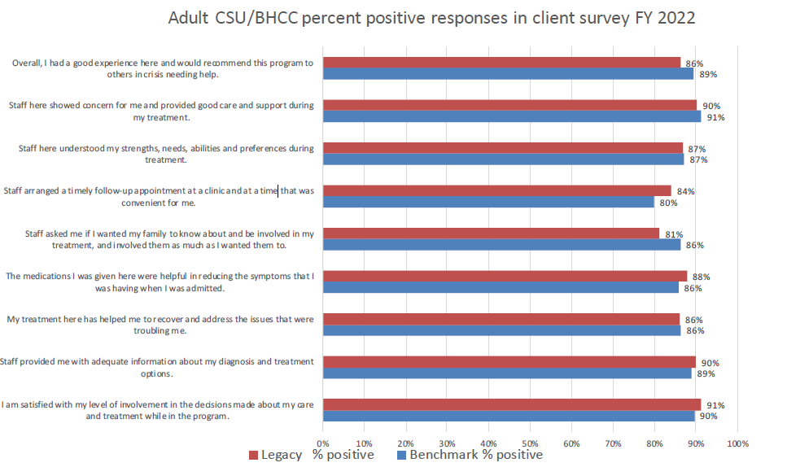

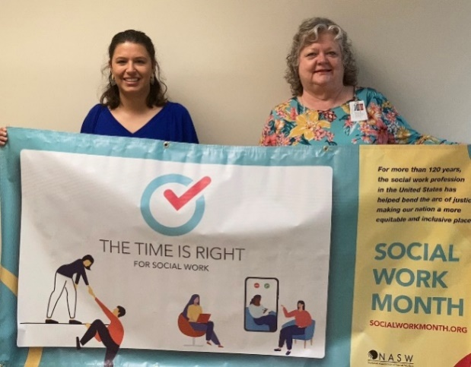

|  |  |
| --- | --- |
| **LBHS Programs** | **Services Offered** |
| Behavioral Health Crisis Center (BHCC) | * Non-hospital Crisis services (SUD/MH/Co-occurring disorders) * Assessment/Triage 24/7/365 * 24-hour Temporary Observation Unit (Temp Ops) -6 beds * Short-term Crisis Stabilization Unit (CSU) -24 beds * Crisis Service Center (CSC)/Walk-in Clinic * Physician and Nurse Practitioner Services, Nursing, Clinicians, CPS, Pharmacist |
| Cook County- Adult & Child/Adolescent Outpatient Clinics  (SUD/Mental Health, Co-Occurring Conditions) | * Individual, Group, & Family Counseling * Wellness, Recovery, & Resiliency Education * Case Management Services * Physician and Nurse Practitioner Services * Nursing Services * School Based Services |
| Lowndes County- Adult & Child/Adolescent Outpatient Clinics  (SUD/Mental Health, Co-Occurring Conditions) | * Individual, Group, & Family Counseling * Wellness, Recovery, & Resiliency Education * Case Management Services * Family Violence Intervention programs * Physician and Nurse Practitioner Services * Nursing Services * School Based Services |
| Tift County- Adult & Child/Adolescent Outpatient Clinics  (SUD/Mental Health, Co-Occurring Conditions) | * Individual, Group, & Family Counseling * Wellness, Recovery, & Resiliency Education * Case Management Services * Physician and Nurse Practitioner Services * Nursing Services * School Based Services |
| Intellectual & Developmental Disabilities (I/DD) Activity Center  (Turner County) | * Community Integration- Group and Individual Services * Pre-Vocational Services |
| West Park I/DD Residential Group Home | * Community residential assistance for individuals with a diagnosis of developmental disabilities. |
| Residential Services  (Midtown, New Heights, Brooks ITR, Heritage, New Outlook Forensic, Graduate, The Bridge, START, Beacon of Hope, Crisis Respite Apartment, Housing Support, Private Home Care) | * Community Housing * Supportive Living * Living skills Development * Medication Management |
| Peer Support Services (PSS) | * Community Integration (adults) * Self-directed recovery activities * Relapse prevention planning |
| Assertive Community Treatment (ACT) | * Integrated AOD/MH, Co-occurring Conditions (adults) * Community-based psychiatric treatment * Assertive outreach * Physician and Nurse Practitioner Services * Psychosocial services, nursing services * A “hospital without walls” |
| Supported Employment (SE) | * Rapid job search assistance * Job coaching and support * Benefits counseling * Strength-based counseling * Integrated care with MH Team |
| High Utilizer Management (HUM) | * Community based support * Linkage, referral, and short-term care coordination for individual with BH challenges and history of high crisis service utilization. |
| Medication Assisted Treatment/Office Based Opioid Treatment Program (MAT/OBOT) | * Screening & Assessment * Physician/APRN, clinician, nursing, CM, CPS services * Closely monitored Medication Assisted Treatments * Care and support provided at the Induction-Stabilization and Maintenance Phases * Harm Reduction Model Approach |
| Programs in Assisting & Transitioning for Homelessness (PATH) | * Outreach * Housing assistance * SUD Treatment * Case Management Services |
| HIV-Testing Program | * Outreach * Confidential testing * Preventive counseling |

**Programs at Glance**

**Changes in Net Positions of LBHS, Governmental Funds**

|  |  |  |  |  |  |  |
| --- | --- | --- | --- | --- | --- | --- |
|  |  | ***2022*** | ***2021*** | ***Difference*** | ***% Difference*** | ***2020*** |
| ***Revenues*** |  | ***\*UNAUDITED*** | ***AUDITED*** |  |  | ***AUDITED*** |
| *Grants and Contributions* |  | 16,691,830 | 13,747,974 | 2,943,856 | 21.41% | 14,067,249 |
| *Charges for services* |  | 15,447,884 | 15,919,176 | (471,292) | -2.96% | 18,052,468 |
| ***Total Operating Revenue*** |  | **32,139,714** | **29,667,150** | **2,472,564** | **8.33%** | **32,119,717** |
| ***Expenses*** |  |  |  |  |  |  |
| *Mental Health Programs* |  | 23,305,000 | 20,619,976 | 2,685,024 | 13.02% | 23,627,555 |
| *Developmental Disabilities Programs* |  | 3,681,047 | 3,258,339 | 422,708 | 12.97% | 2,687,643 |
| *Addictive Disease Programs* |  | 2,272,100 | 2,010,598 | 261,502 | 13.01% | 2,268,851 |
| *Other Programs* |  | 3,184,000 | 2,811,084 | 372,916 | 13.27% | 2,901,491 |
| ***Total Operating Expenses*** |  | **32,442,147** | **28,699,997** | **3,742,150** | **13.04%** | **31,485,540** |
| ***Increase (Decrease) in Net Position*** |  | **(302,433)** | **967,153** | **(1,269,586)** | **-131.27%** | **634,177** |

***ORGANIZATIONAL BUSINESS FUNCTIONS***

Legacy Behavioral Health Services (LBHS) provides mental health, substance use disorder, intellectual and developmental disabilities services to individuals in a 10-county service area. LBHS is a Tier 1 provider for the Georgia Department of Behavioral Health & Developmental Disabilities (DBHDD) functioning under the oversight of the South Georgia Community Service Board (CSB) and making up part of the public safety net for mental health services in the state of Georgia.

“DBHDD’s goal is to build a recovery-oriented, community-based system of care, with the capacity to provide timely access to high-quality behavioral health treatment and support services. Recovery accepts that severe and persistent mental illness, substance use, and co-occurring disorders are long-term conditions that a person will be managing for life. This model signifies a shift from crisis-driven services to a prevention-focused continuum of care that provides sustained support, and is based on the strengths, wellness, and goals of the person in recovery.” (Source: DBHDD)

LBHS is working towards the Certified Community Behavioral Health Center (CCBHC) certification by making changes to existing procedures and practices while working to implement those additional ones that are expectation of becoming certified as a CCBHC.

**5**

**Contract Housekeeping Employees**

**316**

**Employees**

**295.3**

**FTEs**

**22**

**Contract IDD Group Home Employees**

\**Data Presented: As of 6/30/2022*

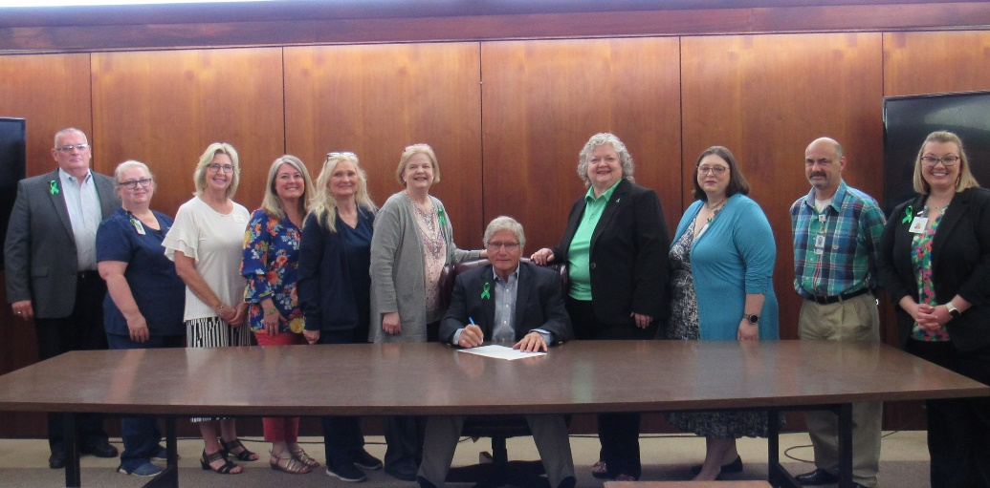

1. **RESULTS**

|  |  |  |  |
| --- | --- | --- | --- |
| ***Business Function Outcomes*** | | ***Target*** | ***Achieved*** |
| ***HR*** | Timely completion of initial departmental training | ≥95% | 73% |
| Timely completion of performance reviews 1) Annual 2) Initial/transfer 90 day | ≥95% | 1)99% 2) 62% |
| Diversity is valued by LBHS (CSB Organizational Climate Survey) | ≥67.06% (CSB Group Mean) | 62.69% |
| Effective Communication (CSB Organizational Climate Survey) | ≥53.23% (CSB Group Mean) | 48.51% |
| Staff turnover rate | <35% | 66% |
| Documentation Timeframe Compliance | All notes completed within 7 days | Not met |
| ***Safety/IPC*** | New employee TB testing requirements are completed timely | 100% | 92% |
|
| Employee Safety: Number of employee injuries | <2 Per Quarter | Avg 0.5 Per Quarter |
| ***Financial*** | Maintain Budget Control | 0% | -.94% |
| Cash in Hand | >30 days | 52.82 days |
| Long-term Debt to Net Ratio | <1 | .21 |
| Current Assets vs. Liabilities ration | >2.5 | 2.42 |
| Provider Productivity | ≥65% | 55% |
|  | Clinician/CSS Productivity | ≥65%/CSS ≥55% | 59%/CSS 50% |

**2. ANALYSIS OF CLIENT-SPECIFIC AND INFLUENCING FACTORS**

During FY22, Legacy BHS was able to serve 7,759 individuals compared to 7,698 individuals in FY21. Of the individual served, 39.9% were Black/African American,.3% were American Indian/Alaska Native/Pacific Islander, 3.2% were Hispanic, and 55.1% were White/Caucasian. Males made up 48.8% of the population, while females made up 51.2%. Health disparities affected racial and ethnic minorities in the ten counties serviced by LBHS due to deficiencies in social determinants of health and economic suffering.

Legacy Behavioral Health Services’ is seeking to become Certified Community Behavioral Health Center (CCBHC) in order to directly address the unmet needs of residents in it’s 10-county service area which includes Ben Hill, Berrien, Brooks, Cook, Echols, Irwin, Lanier, Lowndes, Tift, and Turner counties located in South Georgia. LBHS offers a continuum of care for behavioral health and substance use disorders for youth, adults, and adults with intellectual/developmental disabilities. Our population in focus will include uninsured and underinsured vulnerable individuals with serious mental illness (SMI), serious emotional disturbance (SED), substance use disorders (SUD), co-occurring disorders (COD) and intellectual developmental disorders (IDD). Within our population in focus are ethnic minorities, veterans, L.G.B.T.Q.I.A.+, and children and adolescents who lack access to behavioral health and medical screenings and primary care. Minorities have less access to mental health services than Caucasians, are less likely to receive needed care, and are more likely to receive inferior quality of care when they are treated.

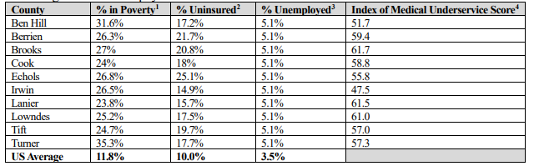

1 https://www.census.gov/quickfacts/fact/table/US/PST045219

2 Ibid.

3 <https://dol.georgia.gov/area-unemployment-rate-and-labor-force-estimates>

4 <http://data.hrsa.gov/tools/shortage-area/mua-find>

Individuals with IDD are at a higher risk for death due to a lack of individualized care and preventive screenings. Assessment and treatment plans, medical care needs, medication management, coordination of care, and inability to respond to an emergency or change in condition in a way that would preserve the individual's welfare were all examples of deficiencies. Six of the top ten causes of mortality in the IDD population are also among the top ten causes of death in the United States and Georgia: heart disease, respiratory illness, COVID-19, cancer, pneumonia, and renal disorders. Four of the main causes of mortality for Individuals with IFF include sepsis, disability, aspiration pneumonia, and seizures. As a result, focus has been and continues to be to facilitate and coordinate the care for individuals with IDD so that their medical needs are met.

All ten counties in the catchment area are designated Medically Underserved Areas and Health Professional Shortage Areas for Primary Care and Mental Health. Individuals with disabilities face health disparities nationwide, and are similarly underserved in rural Georgia, with limited access to appropriate resources. It is crucial that individuals with co-occurring intellectual/developmental disabilities and behavioral health/mental illness challenges have increased access to health services that meet both physical and behavioral needs to support overall wellness and an increased quality of life.

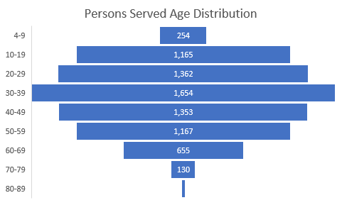

**3. OTHER CIRCUMSTANCES**

Staff Shortages in many clinical areas and other key positions continue to negatively impact operations. These shortages are the results of many factors which include supply versus demand; COVID-19 related personal health and safety concerns; quarantine of employees causing additional workload on remaining staff; pandemic/workload stress; geographical location; and increased labor focus on work life balance and personal time, with a resultant decrease in employee work availability and productivity.

**4. SUMMARY FINDINGS, RECOMMENDATIONS, AND ACTION PLAN**

FY 2022 results include an 8.33% increase in total revenues and 13.04% increase in expenses. The increases in both revenues and expenses are primarily the result of additional programs and services made possible through grant funds awarded throughout the fiscal year.

Fee for service revenues decreased 3% year over year. Low patient volumes compared to pre-pandemic levels, and staffing shortages in key clinical positions continued to be operational challenges.

FY 2023 will continue with same challenges, in addition to unprecedented inflation growth in wages and non-salary expenses. LBHS will continue to be cost effective, efficient, and creative while engaging persons served, staff and community in a variety of venues and environments to face and overcome these challenges.

**FY22 ACTIONS TAKEN:**

***֍ FISCAL***

* *Applied for SAMSHA grants to support implementation of CCBHC patient care model.*
* *Applied for and received SAMSHA grant to support our efforts to treat OPIOID use in rural areas.*
* *Applied for and received DBHDD grant to expand Georgia Housing Voucher Program and housing support services to the 24 counties within DBHDD’s Region 4.*
* *Continuous focus on non-salary expense reduction.*
* *FY 2023 budget implemented with a zero-budget increase in revenues and modest 5% increase in expenses.*
* *Focused on cash preservation.*

***֍ HUMAN RESOURCES***

* *Successfully hired key support roles including Quality Data Analyst, Data Entry Specialist, and Business Intelligence Specialist.*
* *Implemented an Executive DEI Council and a monthly review of employee demographics.*
* *Successfully updated/revised all organizational plans and program scopes of care.*
* *Revised Staff Training Plans to reflect a tiered learning approach based upon job description.*
* *Established an employee Engagement Committee.*
* *Obtained grant funds to support paid therapy interns in APEX program up to 300 hrs. per semester*
* *Participated in State of Georgia workforce recruitment and retention initiatives.*

***֍ INFORMATION TECHNOLOGY***

* *Developed Data Management Plan*
* *Finalized Data Metrics Listing*
* *Initiated Data Mapping*
* *Implemented multi factor authentication for Netsmart EMR.*
* *Installed new digital voice recognition dictation software and hardware for clinicians.*
* *Implemented e-signature functionality for patient intake forms.*

*֍* ***SATISFACTION OF PERSONS SERVED & STAKEHOLDERS***

* Participated in specific satisfaction surveys for Stakeholders, Supported Employment, PATH and Peer Support Services programs.
* Maintained high satisfaction feedback scores on MSHIP (Adult and C/A), GADDSS, and BHCC surveys.
* Implemented IDD and Mental Health Advisory Councils with persons served and stakeholder representation.

**AREAS FOR IMPROVEMENT:**

* Staff Recruitment & Retention: Continue to implement and improve Recruitment and Retention Plan for therapists, associate therapists, nurse practitioners, nurses, and peer specialists.
* Onboarding/Offboarding Process: Utilize Dayforce software to improve the onboarding/offboarding process for all employees.
* Organized a focused work group to review and improve the onboarding/off boarding process
* Continue to expand employee wellness program.
* Improve productivity and workforce efficiencies in delivery of high-quality services.
* Recruit and Employ a Compliance Auditor to review, monitor and report to help maintain compliance with regulatory guidelines.

**COMPLETION OF ACTION PLAN FY22**

* Become CCBHC certified (Timeline: 09/22) ***Ongoing***
* Implementation of 988 (Timeframe: 7/22) ***Goal Achieved; State level implementation only***
* Implement Centralized Scheduling (Timeframe: 1/22) ***Ongoing***
* Facilitate primary care screenings for uninsured individuals (Timeframe: 06/22) **Ongoing**
* Improve data collection and automated reporting (Timeframe: 05/22) ***Ongoing***
* Implement Jail outreach program (Timeframe: 02/22) ***Completed***
* Development of On-boarding program (Timeframe: 06/22) ***Ongoing***
* Develop/finalize recruitment and retention plan: (Timeframe: 06/22) Ongoing

**ACTION PLAN FY23**

* Hire High Utilization Management Navigator (Timeframe: 10/1/2022)
* Implement co-responder program (Timeframe: 4/1/2023)
* Complete necessary MOUs to support CCBHC implementation. (Timeframe: 12/1/2022)
* Hire/contract Primary Care Provider (Timeframe: 12/1/2022)
* Submit DBHDD grant to support CCBHC implementation (Timeframe: 11/1/2022)
* Recruit and employ Compliance Auditor (Timeframe: 1/1/23)
* Work with community partners to establish Valdosta/Lowndes NAMI chapter (Timeframe: 10/1/2022)
* Increase persons served, stakeholder participation on Advisory Councils MH to 20, IDD to 10 (Timeframe: 11/1/2022)
* Initiate Co-Responder Program (Timeframe: 12/1/2022)

**BEHAVIORAL HEALTH CRISIS CENTER (BHCC)**

LBHS Behavioral Health Crisis Center (BHCC) provides crisis emergency services 24/7 for adults aged 18 and older with mental health, substance use disorder (drugs, alcohol), and co-occurring disorders. The BHCC is located in Lowndes County, Valdosta, Georgia.

***Crisis Service Center (CSC)*** provides

**5.6%**

**Decrease from FY21**

**1572**

**Unique Individuals Served**

short-term 24/7, facility based, walk-in

psychiatric/substance related crisis evaluations

and brief intervention services to support an

individual who is experiencing an abrupt and

substantial change in behavior noted by

severe impairment of functioning, typically

associated with a precipitating situation or

**222**

**Individuals Had more than 2 visits to the CSU**

marked increase in personal distress.

***Temporary Observation Unit*** is a facility-based

program that provides a physically secure and

medically safe environment during which an

individual in crisis is further assessed, stabilized, and

referred to the next appropriate level of care

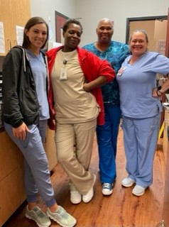(Generally, within 24 hours). Temporary observation

unit has 6 beds.

***Crisis Stabilization Unit (CSU)*** is a residential alternative

to or diversion from inpatient hospitalization, offering

psychiatric stabilization and withdrawal management

services. The program provides medically monitored

residential services for the purpose of providing

psychiatric stabilization and substance withdrawal

management services on a short-term basis.

1. **RESULTS**

|  |  |  |  |
| --- | --- | --- | --- |
| ***BHCC Program Outcomes*** | | ***Target*** | ***Achieved*** |
| ***Effectiveness*** | # Of ASO discharges not completed within 72 hours of discharge | 0 | Total of 11 errors |
|  | % Of Initial Nursing Assessments completed within 1 hours from the admission | 100% | Monthly Avg 77% |
|  | Individuals with primary or co-occurring diagnosis of SUD will attend SUD counselling group | 70% will have 1 or more groups | 58% |
|  | Decrease the use of restraints | ≤2 per month | 2.25 per month |
|  | Decrease the use of seclusions | ≤5 per month | 3.9 per month |
|  | CSSR screening is completed during initial intake | 100% | 99% |
| ***Efficiency*** | CSU LOS | ≤7 days | 6.1 days |
|  | Temporary Observation Unit LOS | ≤1 day | 1.09 days |
| ***Service Access*** | Persons served will have access to crisis services (KPI CSU 1.1) | ≥90% | 100% |
|  | Temporary Observation Unit Diversion Rate (KPI BHCC 1.2) | ≥50% | 52% |
| ***Satisfaction*** | Persons served will report overall satisfaction with the care provided | ≥90% | 86% |
|  | Stakeholders will be satisfied with services | ≥85% | 100%* FY21 |

1. **ANALYSIS OF CLIENT-SPECIFIC EXTENUATING AND INFLUENCING FACTORS**

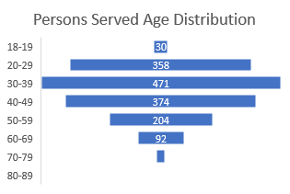

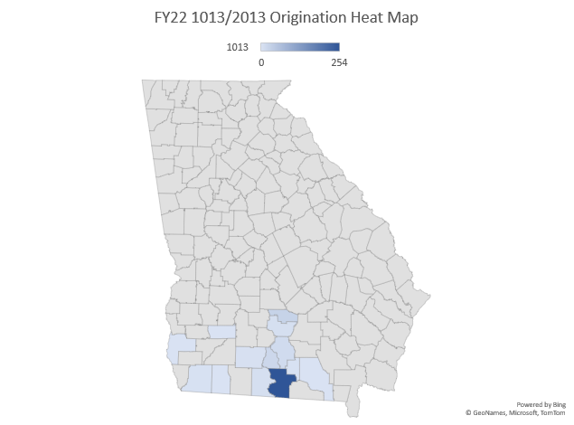

Care and treatment of Individuals with diagnosis of Intellectual and developmental diseases (IDD) and co-occurring behavioral health related issues is a special population that requires additional staff training and increased co-operation among care providers internally as well as with the community providers. Since LBHS serves individuals with IDD at the residential sites as well as day programs, we were able to use the knowledge of the IDD staff to help the crisis unit brainstorm solutions to manage the care for those admitted with the IDD diagnosis. This past year has clearly shown that a cap exists for individuals with IDD and co-occurring behavioral health related issues.

1. **OTHER CIRCUMSTANCES**

While responding to the ongoing COVID-19 variants, BHCC continued to provide uninterrupted care. Staffing challenge have included the uncertainly of available staff due to testing positive for the COVID-19. In addition, there has been a lack of therapy staff to fill vacant night and weekend vacancies. This has necessitated LBHS obtaining staffing waivers from the DBHDD. The ability to hire certified peer specialists to provide daily services is another gap that BHCC is working to close.

Persons served experienced an increase in severeness of mental health crisis, which was increased on decreased diversion rates from temporary observation unit to the community. During FY22, we were able to divert 52% of the individuals while the FY21 diversion rate was 57%. Also, the CSU LOS has increased slightly up to 6.1 days. Overall, CSU occupancy rate increased 2% from the previous year. LBHS BHCC continues to provide a significant service for the Community by providing crisis assessment and evaluation for 100% of individuals seeking for services.

Care coordination with LBHS services as well as other community providers has been one of the priority areas. A great amount of work has been dedicated towards expanding coordination of care activities to both provide access to post discharge services and engage individuals with their care.

**4. SUMMARY FINDINGS, RECOMMENDATIONS, AND ACTION PLAN**

**ACTIONS TAKEN FY22**

* Hired a bilingual English/Spanish speaking Nurse Manager for BHCC
* Revised the discharge process to include coordination of transportation for the pharmacies and laboratories as needed to improve continuity of care.
* Implemented EBP- Living in Balance, with the SUD groups
* Suicide Prevention Taskforce revised the suicide prevention policy and staff training plan
* Continued to provide training for local law enforcement
* Collaborated with the IDD staff to provide more population-based care
* Developed new electronic reports to monitor 1013/2013 admissions
* Revised several key policies
* Improved the timeliness to obtain UDS results
* Improved the communication with the OP providers for improved care coordination
* Revised the chart audit process
* Successfully passed the ASO audit
* Participated in collaborative meetings with local regional hospitals, Benchmark Crisis Response Team, Local Sheriffs’ Offices, and Region IV representatives.
* Changed designated restrooms to gender neutral restrooms and improved signage
* Actively participated in community advocacy for suicide prevention
* Group room was reworked to improve acoustics and communication by adding carpet and large screen monitor
* Increased emergency food supply

**AREAS FOR IMPROVEMENT**

* Complete Implementation of all orders & documentation into electronic format.
* Revise Discharge documentation
* Develop and implement additional reports for clinicians and leadership in order to reduce time spent on collecting data.
* Continue to recruit additional clinicians to meet DBHDD staffing requirements.
* Continue to recruit additional CPS specialists to meet DBHDD staffing requirements.
* Train additional staff to care for Individuals with IDD and co-occurring diagnosis
* Actively support community groups in implementation of a local NAMI chapter
* Increase community awareness for crisis services
* Work on implementation of a restraint’s free environment and revise staff training plan

**COMPLETION OF ACTION PLAN FY22**

* Decrease temporary observation LOS to 23 hours (Timeline: 11/2021) ***Goal not achieved***
* Increase Temporary Observation diversion rate to 50 % or more by referring persons served to community rather than transferring them to the CSU (Timeline: 09/2021). ***Goal Achieved***
* Revise the Nursing Assessment so it can be completed within 1 hour from admission to CSU (Timeline: 10/2021). ***Goal Achieved***
* 70% of individuals with a primary or co-existing diagnosis of SUD will attend 1 or more SUD counseling groups (Timeline: 11/2021). ***Goal not achieved***
* Meet with one community stakeholder per month to educate them on BHCC and LBHS services (Timeline: 09/2021). ***Goal Achieved***
* Revise the quality Assurance Process for licensed staff on completing CSSRs (Timeline: 11/2021). ***Goal Achieved***
* Improve clarity of service location documentation on EMR (Timeline: 09/2021). ***Goal Achieved***
* Facilitate the access of persons served to post discharge psychiatric medications and the individual’s ability to access and afford medication how the medication will be obtained after five-day supply is exhausted, including how any associated lab work will be accessed and funded (Timeline: 09/2021). ***Goal Achieved***
* Clinical Leadership Team will develop and approve annually the therapeutic content of the program (group therapy/training, individual therapy/training, education support, etc.) (Timeline: 11/2021). ***Goal Achieved***
* Employ another Certified Peer Specialist so there is coverage for 7 days a week from 8 am-7pm (Timeline: 11/2021). ***Goal not achieved***
* Cross train designated employees to assist in different areas of service (for example, HSTs train in Pre-Service) (Timeline: 11/2021) ***Goal Achieved***
* Add braille to all BHCC signage (Timeline: 04/2022) ***Goal not achieved***
* Coordinate post discharge care to meet KPI 3.1 and KPI 3.2 goals (Timeline: 10/2021). ***Goal partially achieved***
* Meet the financial budget expectations (Timeline: 06/2022). ***Goal not achieved***

**ACTION PLAN FY23**

* Decrease staff overtime to max 5% compared to FY21 with staff redesign, improved leadership monitoring, and recruitment (Timeframe: 10/1/2022)
* Hire two new therapists (Timeframe: 09/1/2022)
* Redesign the treatment team format (Timeframe: 11/1/2022)
* Engage CSU discharges with the provider minimum 75% to have MD/APRN evaluation within 14 days (Timeframe: 08/1/2022)
* Decrease requests to EMT transportation to max 4 per month (Timeframe: 09/1/2022)
* Hire Clinical Team Leader (Timeframe: 11/1/2022)
* Revise group schedules for CSU (Timeframe: 10/1/2022)
* Improve clinical wok flow of evaluations/admissions from the CSC to Temporary Observation Unit and CSU (Timeframe: 11/1/2022)

**OUTPATIENT ALCOHOL and OTHER DRUG/MENTAL HEALTH (AOD/MH) SERVICES** – Adult, Child & Adolescence

Legacy outpatient programs include but are not limited to, individual, group, and family counseling/education on wellness, recovery, and resiliency for individuals aged four (4) and older. These programs offer coordinated and defined services, that may vary on intensity, based on the individual’s needs. Outpatient programs can address a variety of stressors, family relations, interpersonal relationships, mental health issues, life span issues, psychiatric illnesses, substance use disorders and other addictive behaviors.

LBHS provides clinic-based services for children and adolescents, family therapy and school-based services (Apex Program) at 23 elementary, middle, and high schools in four (4) different counties. Individuals who are 18-21 years of age and are still enrolled in school, may continue services through the child and adolescent programs.

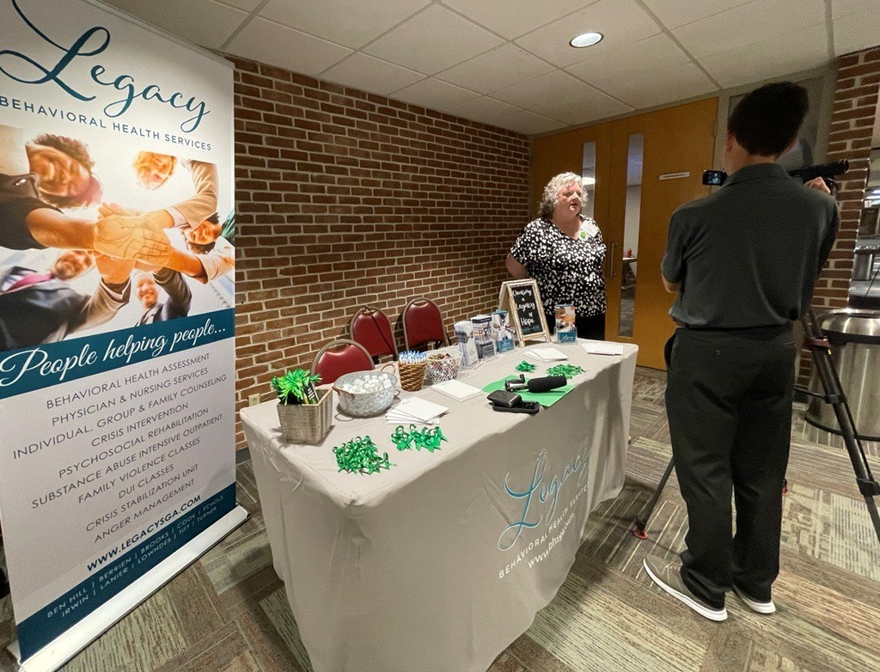

**78**

**Enrolled in APEX Program**

**141**

**Enrolled in APEX Program**

**627**

**Enrolled in CM**

**3,553 CM Visits**

**363**

**Enrolled in CM**

**3,591 CM Visits**

**Physician Visits**

**3,217 Adult**

**698 C&A**

**16,904 Visits**

**48.5% Completed by Telehealth**

**2,504**

**Persons Served**

**Cook County Op Clinic (C&A, Adult)**

**Physician Visits**

**4,609 Adult**

**849 C&A**

**21,706 Visits**

**38.9% Completed by Telehealth**

**3,012**

**Persons Served**

**276**

**Enrolled in APEX Program**

**811**

**Enrolled in CM**

**6,681 CM Visits**

**Physician Visits**

**9,317 Adult**

**2,024 C&A**

**38,840 Visits**

**40.4% Completed by Telehealth**

**4,717**

**Persons Served**

**Tift County OP Clinic (C&A, Adult)**

**Lowndes County OP Clinic (C&A, Adult)**

**58**

**Referred by Accountability Courts**

**56**

**Referred by Accountability Courts**

**71**

**Referred by Accountability Courts**

* + - 1. **RESULTS**

|  |  |  |  |
| --- | --- | --- | --- |
| ***Outpatient Program Outcomes*** | | ***Target*** | ***Achieved*** |
| ***Effectiveness*** | Individuals with primary or co-occurring SUD diagnosis will have group counseling (KPI 5.2 Adult) | ≥75% | 20% |
|  | Individuals with primary or co-occurring SUD diagnosis will have group counseling (KPI 5.2 Child/Adolescent) | ≥75% | 19% |
|  | Therapists will use CANS consistently to support decision making | ≥75% | 77% |
|  | Suicide Prevention Screening and Planning for ADULTS   * suicide screening CSSR is done during initial intake * each time suicidal ideation is indicated it is addressed on the treatment plan * each time suicidal ideation is identified safety plan is created   Suicide Prevention Screening and Planning for CHILD/ ADOLESCENTS   * suicide screening CSSR is done during initial intake * each time suicidal ideation is indicated it is addressed on the treatment plan * each time suicidal ideation is identified safety plan is created | 100%  100%  100%  100%  100%  100% | 98%  86%  97%  97%  88%  99% |
| ***Efficiency*** | Nursing documentation is done timely for individuals with SUD diagnosis   * Initial Nursing Assessments are done within 30-days from initial therapy intake * Annual Nursing Assessments are done timely | 100%  100% | 17%  37% |
|  | Treatment Plan Reviews for SUD individuals are completed timely | 100% | 80% |
| ***Service Access*** | C/A served in Apex programs will have family involvement 20% of all visits | 20% | 11% |
|  | CSS visit frequency | Min. 2.0/ individual/ month | 3 |
|  | Persons Served are seen in timely manner by clinician after hospital discharge (KPI 3.1) | ≥75% | 78.43% |
|  | Adults are seen in timely manner by providers after hospital discharge (KPI 3.2) | ≥75% | 66.92% |
|  | No show rate for Initial Treatment (KPI 4.2) | ≤15% | 10.92% |
|  | No show rate for Initial Psychiatric Evaluations (KPI 4.3) | ≤15% | 10.10% |
|  | C/A are seen in 4 days manner by therapist  C/A are seen in 14 days by providers | ≥75%  ≥75% | 68%  72% |
| ***Satisfaction*** | Persons served will be satisfied with services received   * % Of persons served will report staff being encouraging of his/her growth, change and recovery * % Of persons served will report improved social connectedness   Stakeholders will be satisfied with services received   * % Of stakeholders reporting respectful and cordial communication | ≥80%  ≥85%  ≥85% | 87%  93%  100% *FY21 |

1. **ANALYSIS OF CLIENT-SPECIFIC EXTENUATING AND INFLUENCING FACTORS**

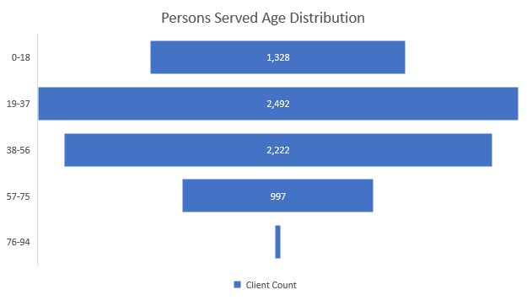

Persons Served Employment Status

**17%**

**Persons Served Reported being Retired or Disabled**

**19%**

**Persons Served Reported being Unemployed, Seeking Employment**

**18%**

**Persons Served Reported being Employed**

OP Services Residential Status

**1%**

**Reported Supported/Supervised Housing**

**6%**

**Reported Homelessness/ Lacking A permanent Residence**

**86%**

**Reported Living in Private Residence**

1. **OTHER CIRCUMSTANCES**

The temporary waiving of regulations around telehealth by the US government initiated on March 17, 2020, remained in place for the entire FY22. During the COVID-19 pandemic, both federal and state emergency response designations increased the ability of CSBs to utilize telehealth services. Around 40% of the outpatient visits were completed utilizing telehealth instead in clinic face-to face. Many of these visits were done based on the request from the individuals served to make their access more convenient.

A critical issue for LBHS has been staff shortages exasperated by the ongoing pandemic and additional requirements that are required for CSB clinicians, such as additional paperwork when compared to private practices. This ongoing labor shortage has negatively affected operations throughout FY22 and continues into FY23. However, this issue is not unique to LBHS and mental health generally but is rather a national trend in health care.

Outpatient clinics have increased ongoing monitoring of processes/outcomes and increased EBP. Many processes have been revised with the goal of reducing waste and maximizing clinical care time. OP clinics have been instrumental in improving care coordination among providers by working hand in hand with other departments such as pre-service, PATH program, MAT/OBOT Program, Supported Employment, BHCC, and others.

**3. SUMMARY FINDINGS, RECOMMENDATIONS, AND ACTION PLAN**

OP clinics showed an improvement in clinical care models as reflected on the June 2022 ASO Quality Review with the overall score of 96%. Care coordination, with the focus of whole person health, is evidenced by connecting individuals served with primary care, dental care, and other needed services. Attention is paid to nutritional counselling, weight monitoring and metabolic monitoring. Group treatments address the physical, mental, and spiritual wellbeing including social engagement and accountability.

The suicide prevention taskforce has focused on strengthening documentation on alerts for high-risk individuals. Crisis plans include clinically valuable information in the event of a crisis, including the preferences of the individuals served.

**ACTIONS TAKEN FY22:**

* Clinical staff participated in the community wide educational events on suicide prevention including Question, Persuade, and Refer (QPR)) and Mental Health First Aid for children and adults
* Hired experienced SUD Program Coordinator
* Revised several clinical polices including Suicide Prevention Policy
* Started using additional evidence-based practice models such as Living in Balance
* LBHS staff participated in training programs including DBHDD Clinical Development Academy, DBT Training, MRT facilitator, and SBI facilitator
* Initiated construction to move Cook County OP clinic to a new building
* Redesigned the chart review process
* Initiated centralized scheduling at the Cook OP
* Initiated an electronic referral tracking template
* Initiated Jail-in-Reach Program with Lowndes County Jail.

**AREAS FOR IMPROVEMENT:**

* Create additional real time reports that can use to manage workflows more efficiently.
* Continue to focus on CCBHC readiness and staff education requirements.
* Relocate Cook County OP Clinic
* Transition all clinicians from self-scheduling to centralized scheduling to improve access to care and efficiency.
* Improve access to care (MD/APRN) after hospital discharges
* Prioritize new intakes based on severity (crisis, urgent, and routine needs) to focus on need and timeliness for services.
* Work to improve engagement with individuals served, especially for those with SUD related co-occurring diagnosis who are not enrolled in SUD services.
* Focus on individual involved in law enforcement

**COMPLETION OF ACTION PLAN FY22:**

* Hire a qualified candidate for the SUD Coordinator position (Timeline 10/1/2021) ***Completed***
* New employee retention rate to be 60% or higher (Timeline 5/30/2022) ***Ongoing***
* Staff vacancy rate is not to exceed 20% (Timeline 5/30/2022) ***Ongoing***
* Develop and strengthen educational relationship with VSU for increased internship placements (Timeline 3/20/2022) ***Completed***
* Secure a grant for the C&A Mental Health Resiliency Support Clubhouse program (Timeline 5/30/2022) ***Goal Not Achieved***
* Increase the number of qualified staff members trained in QPR to 4 individuals and Mental Health First Aid to 2 individuals (Timeframe 4/30/2022) ***Completed***
* Increase Apex services at new locations: Tift County Middle Schools, Lanier County, and Brooks County schools (Timeline 5/30/2022) ***Ongoing***
* Creation of Workflows and Care Pathways to improve and standardize processes across all service lines (Timeline 4/30/2022) ***Ongoing***
* Provide staff education on CCBHC provider model and service expectations (Timeline 5/31/2022) ***Ongoing***
* Relocate Cook County OP Clinic (Timeline 6/1/2022) ***Ongoing***
* Transition clinicians from self-scheduling to centralized scheduling to improve access to care and efficiency. (Timeline 4/30/2022) ***Ongoing***
* Improve access to care with improved workflows and expanded hours to meet the DBHDD KPIs (Timeline 6/30/2022) ***Completed***
* Demonstrate measurable improvements in care coordination of hospital discharges (KPI 3.1 and KPI 3.2) (Timeline 1/20/2022) ***Completed***
* Improve the process of chart reviews to focus on quality and timeliness of care with improvement plans. (Timeline 12/20/2021) ***Completed***
* Improve engagement with individuals served to meet the KPI targets set by DBHDD on no show rates (Timeline 1/30/2022) ***Completed***
* Improve engagement for individuals with co-occurring diagnoses in MH and SUD services. Measure engagement on DBHDD KPI on SUD groups (Timeline 6/30/2022) ***Goal Not Achieved***
* Initiate focused case management protocols to improve quality of care (Timeline 3/30/2022) ***Goal Not Achieved***

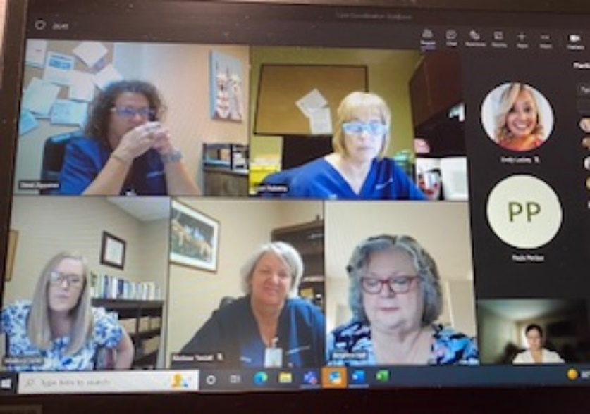

**ACTION PLAN FY23:**

* Participate on NAMI Lowndes initiative (Timeframe: 8/1/2022)
* Engage employees to participate in community events, such as NAMI Walk, Suicide prevention training, Suicide prevention Run (Timeframe: 9/1/2022)
* Increase engagement for hospital discharges to be seen within 14-days by MD/APRN (Timeframe: 11/1/2022)
* Improve engagement for individuals with co-occurring diagnoses in MH and SUD services. Measure engagement on DBHDD KPI on SUD groups (Timeframe: 11/1/2022
* Initiate focused case management protocols to improve quality of care (Timeframe: 10/1/2022)
* Improve staff efficiency providing access to care (Timeframe: 9/1/2022)
* 100% of clinician appointments are scheduled by centralized scheduling (Timeframe: 11/1/2022)
* Hire 3 therapists (Timeframe: 09/1/2022)
* Hire 3 additional therapists (Timeframe: 12/1/2022)
* Redesign nursing workflow to improve access to nursing care (Timeframe: 09/1/2022)
* Initiate preventive screenings such as AUDIT and QPR-9 (Timeframe: 101//2022)
* Initiate Co-responder program (Timeframe: 12/01/22)

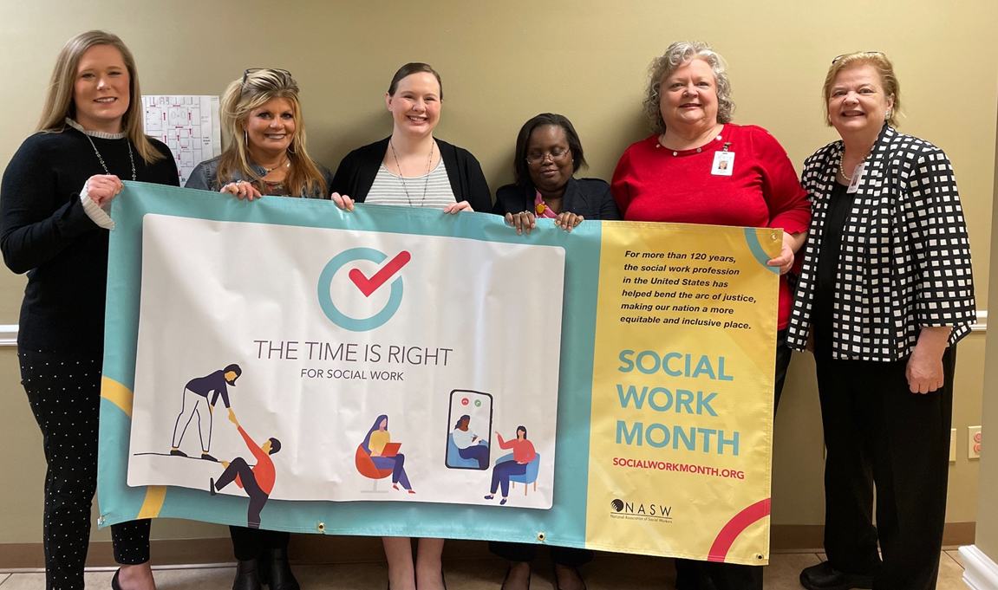

**ADULT ASSERTIVE COMMUNITY TREATMENT (ACT)**

Assertive Community Treatment (ACT) is an intensive, highly integrated treatment model that provides multidisciplinary, flexible treatment and support to individuals with mental illness including 24/7 crisis support. This model is based on the principle that individuals receive better care when their mental health care providers work closely together on a community-based mental health service delivery. The ACT team serves individuals with the most serious forms of mental illness, predominantly but not exclusively the schizophrenia spectrum disorders. The LBHS ACT team serves six counties: Lowndes, Cook, Brooks, Berrien, Echols, and Lanier. Individuals in other counties receive ACT services form two other CSBs.

**82**

**Persons Served**

**1. RESULTS**

|  |  |  |  |
| --- | --- | --- | --- |
| ***ACT Program Outcomes*** | | ***Target*** | ***Achieved*** |
| ***Effectiveness*** | Persons served will have reduction in episodes of incarcerations | ≤8% | 7% |
|  | Persons served will have reduction in number of ED visits | ≤5% | 5% |
| ***Efficiency*** | % Of Persons served will receive adequate support- Average number of 3 face-to-face visits per week | 100% | 21% |
| ***Service Access*** | % Of natural support contacts per month (3 or more) | 100% | 43% |
| ***Satisfaction*** | Persons served will report social connectedness   * % Of persons served will report feeling of belonging to their community   Stakeholders will be satisfied with services received   * % Of stakeholders reporting respectful and cordial communication | ≥70%  ≥85% | 77%  100% *FY21 |

**2. ANALYSIS OF CLIENT-SPECIFIC EXTENUATING AND INFLUENCING FACTORS**

Two thirds of the individuals served by the ACT Team are men (66%), only 33% being women. Of all individuals 60% are African American, with largest age group served being 36-53 years of age. Due to the severity of the population served only 2 individuals were employed at the time of admission at some level. ACT individuals need intensive services and care coordination which also affects the housing situation. One third of individuals enrolled in ACT experienced homelessness, incarceration, or were living in other supervised housing arrangement at one point during FY22.

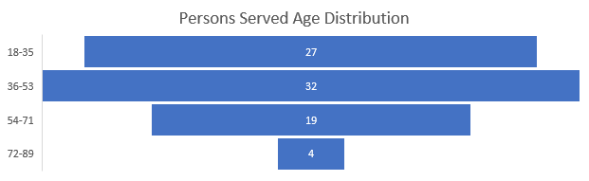

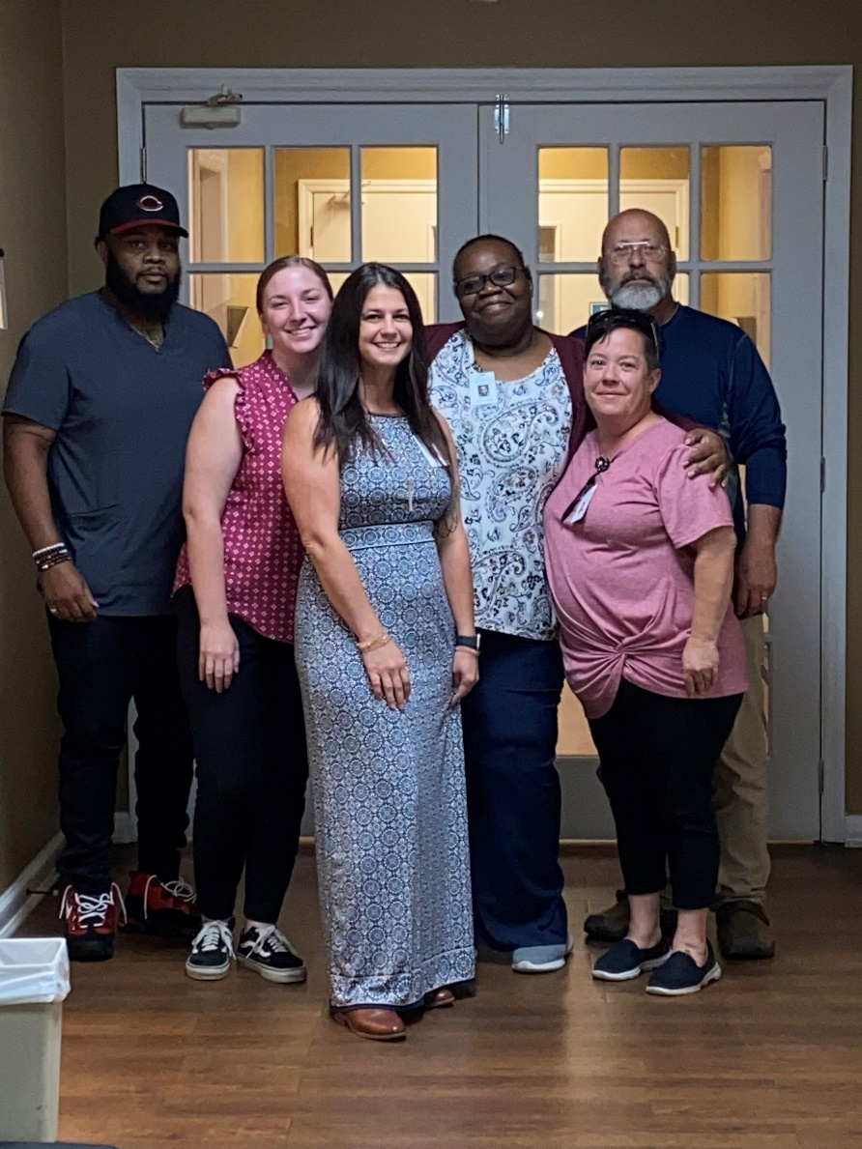**3. OTHER CIRCUMSTANCES**

By the nature of the individuals served in the ACT program, many issues are widespread due to lack of natural supports.

Many times, individuals are hard to be located which makes it hard for them to receive face-to-face services compliant with the medication management. Their fear of the pandemic and getting severely sick, has made it more challenging for the ACT team to provide services. However, with the resiliency and commitment of the ACT staff and with the leadership of their new Team Leader, the team continues to remove barriers for those individuals receiving ACT services so that they can continue functioning in the community settings.

**4. SUMMARY FINDINGS, RECOMMENDATION, AND ACTION PLAN**

ACT team members are included in CSU team meetings and the BHCC is tasked to contact the ACT team immediately when an ACT enrolled individual arrives at the Crisis Center. The ACT team member, who has deeper knowledge of the individual, may be able to respond to the needs of the individual, thereby eliminating the necessity for an admission to the CSU and ensure that the medical care is well coordinated so the individuals don’t end up in the hospital emergency departments. The constant communication with parole officers has helped to keep the individuals out of jails, with the monthly average of individuals having episodes of jail/prison stays being at 7 %. During the FY22, the ACT team also had significant staff shortages which limited their ability in the provision of face-to- face services.

**ACTIONS TAKEN FY22:**

* Hired a Team Leader
* Worked with IT to implement additional reports to improve accuracy and reduce time to collect data
* Continued to educate persons served on proper infection control protocols during COVID-19 pandemic
* Improved cooperation with the Behavior Health Crisis Center and Residential Services to improve housing stability and to avoid unnecessary inpatient admissions.
* Continued close collaboration with local Emergency Department to divert ACT individuals from ED unless there was a medical emergency.

**AREAS FOR IMPROVEMENT:**

* To move all documentation into an electronic format
* To Implement organized Individualized Treatment Team meetings
* Implement improved care coordination and primary care screenings for all ACT individuals
* Implement formal memorandums of understanding (MOUs) with community partners
* Hire clinician
* Hire Vocational Specialist
* Hire Certified Peer Specialist

**COMPLETION OF ACTION PLAN FY22:**

* Implement a search for an ACT Team Leader (Timeline 10/1/2021) ***Goal Achieved***
* Revise nursing assessment to include periodic primary care screenings (Timeline 2/1/2022) ***Goal Achieved***
* Obtain finalized MOUs with community providers to improve care coordination (Timeline 3/30/2022) ***Ongoing***
* Create electronic forms to replace paper forms (Timeline 3/20/2022) ***Ongoing***
* Improve engagement with individuals served to meet the KPI targets set by DBHDD on no show rates (Timeline 1/30/2022) ***Goal Achieved***
* Implement same day documentation (Timeframe 1/30/2022) ***Goal Achieved***
* Educate and train ACT individuals on personal disaster preparedness and planning (Timeframe 3/30/2022) ***Goal Achieved***
* Provide staff training on diversity (Timeframe 5/20/2022) ***Goal Achieved***

**ACTION PLAN FY23:**

* Hire clinician (Timeframe: 08/1/2022)
* Hire Vocational Specialist (Timeframe: 10/1/2022)
* Hire Certified Peer Specialist (Timeframe: 10/1/2022)
* Obtain finalized MOUs with community providers to improve care coordination (Timeframe: 3/30/2023)
* Create electronic templates to replace paper forms (Timeframe: 3/20/2023)
* Implement effective care coordination process for all individuals (Timeframe: 10/1/2022)
* Implement primary care preventive screening process for all individuals

(Timeframe: 2/2023)

**SUPPORTED EMPLOYMENT (SE)**

Supported Employment (SE) assists and provides techniques on finding competitive employment in the community for individual with mental illness. Services include provision of supports to access benefits counseling; identification of vocational skills and interests; and development and implementation of a rapid job search plan to obtain competitive employment based on the person’s strengths, preferences, abilities, and needs. Services may also include job coaching to assist participants in both obtaining and retaining employment.

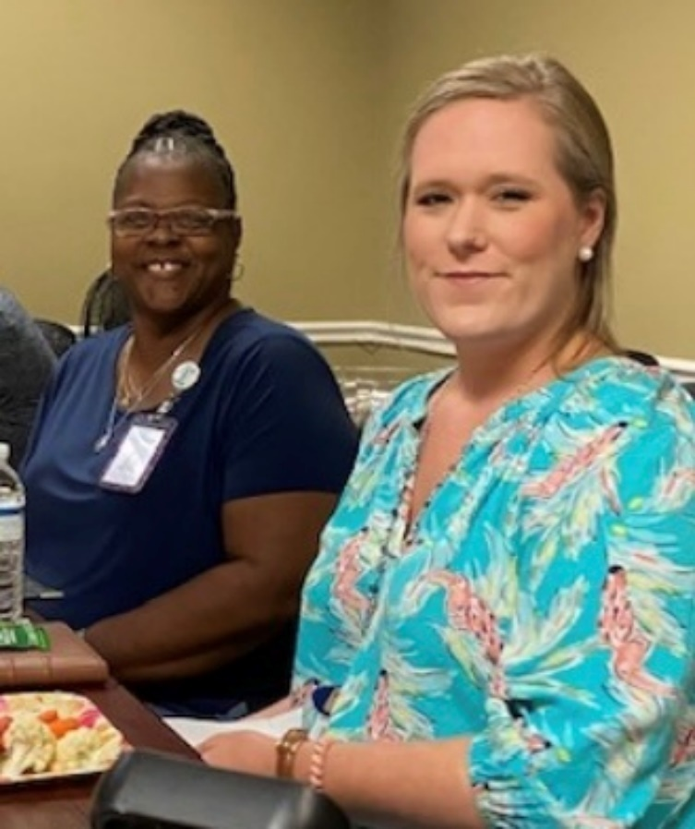

**122**

**Persons Served**

* + - 1. **RESULTS**

|  |  |  |  |
| --- | --- | --- | --- |
| ***Supported Employment Program Outcomes*** | | ***Target*** | ***Achieved*** |
| ***Effectiveness*** | Once individuals obtain employment, the IPS specialist and members of the MH treatment team provide support. 1.# of days to first support  2. Average # support is provided each month  3. The reason to end the support is clearly  documented | 1. ≤7 days  2. ≥2  3. 100% | 1. 3.4 days 2. 2.2 days 3. 100% |
|  | Agent promotes competitive work through multiple strategies. | 100% | 100% |
|  | jobs currently held by IPS clients 1. # of different job titles 2. # or different employers | 1. ≥10 2. ≥6 | 1. 13 2. 12 |
|  | Average days from each client's first appointment with an IPS specialist to fist in-person employer contact by either the client or IPS specialist. | Less than 30 days | Avg 2.4 Days |
| ***Efficiency*** | At least one member of the executive team actively participates in SE leadership team (steering committee) meetings that occur at least every six months for high fidelity programs and at least quarterly for programs that have not yet achieved high fidelity. | 100% | 100% |
|  | Employment specialist are part of Weekly MH treatment teams for which at least 90% of Employment Specialist’s caseload is comprised | ≥90% | 100% |
| ***Service Access*** | Employment specialists have individual employment caseloads, with total of 80 in caseload | Avg Active Caseload per Month 80 | 62 |
| ***Satisfaction*** | SE Supervisor will have minimum monthly contact with benefits navigator to build closer relationship | ≥1 per Month | 1.5 Per Month |
|  | Client’s report Agree-Highly Agree that they received support that they needed after being employed. | 100% | 100% |

* + - 1. **ANALYSIS OF CLIENT-SPECIFIC EXTENUATING AND INFLUENCING FACTORS**

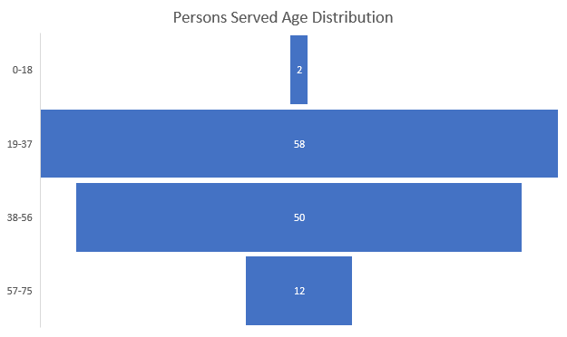

* + - 1. **OTHER CIRCUMSTANCES**

SE team had a change in the leadership position during the past year. With the change in leadership position several processes were reviewed and revised to improve service delivery. The SE staff training program was revised based on the Individual Placement and Support (ISP) model. In addition to external reviews, the program had internal reviews performed to confirm and verify that best practices are carried out on an ongoing basis. Care coordination along with other services provided both internally and externally, including ongoing participation on treatment team meetings, has improved timely response in addressing any ongoing issues. Communication with the Vocational Rehabilitation staff and stakeholders via the SE Steering Committee meetings have provided forum for bringing this important service to the attention of staff, community, and LBHS stakeholders/partners.

**4. SUMMARY FINDINGS, RECOMMENDATION, AND ACTION PLAN**

The total capacity of the SE program with 4.5 FTEs isa caseload of 80 individuals. The SE Census dipped during the months of December and January to 38 individuals, but after a staff position was filled the total census increased to 67 individuals by at the end of FY22. The SE program is actively participating in organizational efforts to provide ongoing quality for persons served. The latest SE Fidelity Review the overall score improved by 9 points from the previous review the total score of 112 points which indicates “Good Fidelity”.

**ACTIONS TAKEN FY22:**

* Hired a new Team Leaders
* Revised the SE Specialist training plan
* Organized quarterly steering committee meetings with executive leadership and community partners
* Improved the SE Fidelity Review score
* Revised the SE brochure
* Initiated SE Satisfaction Survey tool
* Initiated Quality Board for the SE services to keep up with the improvement efforts

**AREAS FOR IMPROVEMENT:**

* Improve the documentation templates to include needed details on services provided
* Improve community awareness in order to serve 80 people at all times
* Increase events to recognize and celebrate individuals’ achievements in the job market

**COMPLETION OF ACTION PLAN FY23:**

* Revise SE specific brochure (Timeline 10/1/2021) ***Goal Achieved***
* Create SE specific satisfaction survey (Timeline 10/30/2021) ***Goal Achieved***
* Have finalized MOUs with community partners (Timeline 3/30/2022) ***Ongoing***
* Improve care coordination by participating on MH treatment team meetings (Timeline 7/30/2021) ***Goal Achieved***
* Schedule internal regulatory reviews bi-annually (Timeframe 9/30/2021) ***Goal Achieved***
* Initiate individual recognition program (Timeline 10/30/2021) ***Goal Achieved***
* Improve care coordination by regularly scheduled meetings with benefits navigator/VR (Timeframe 8/30/2021) ***Goal Achieved***
* Establish quarterly Steering Committee Meetings (Timeframe 9/30/2021) ***Goal Achieved***

**ACTION PLAN FY23:**

* Plan to improve community awareness on SE Services (Timeframe 11/1/2022)
* Revise documentation templates (Timeframe: 12/1/2022)
* Improve the number of satisfaction surveys completed to 70% of all individuals discharged from the services (Timeframe 10/1/2022)
* Improve SE Fidelity score by improving working with the WIPA office to ensure that individuals served will get the most out of their benefits/start receiving benefits i.e., SSI/SSDI

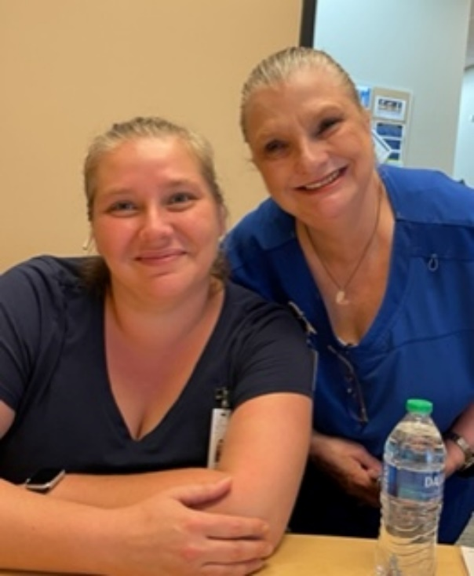**PEER SUPPORT SERVICES (PSS)**

All individuals with a lived experience of mental health challenges or substance use disorders can provide peer support. A Certified Peer Specialist (CPS) is trained to use their personal recovery to the benefit of others who live with behavioral health challenges. CPSs assists participants in the areas of setting recovery goals, building wellness tools, and establishing and maintaining healthy support networks. CPSs promote hope, empowerment, self-advocacy, personal accountability, and self-determination by using their lived experiences with mental health challenges as the foundation to help others learn and believe that recovery is possible for everyone.

**1. RESULTS**

Since the Peer Center has not been functioning since the beginning of the COVID-19 pandemic, no program specific indicators were monitored and collected during FY22.

**2. ANALYSIS OF CLIENT-SPECIFIC EXTENUATING AND INFLUENCING FACTORS**

Peer services were provided at the sites like BHCC and residential services. Therefore, client specific demographic information specifically is not reported.

**3. OTHER CIRCUMSTANCES**

During the FY22 Peer Center was not functioning, however, peer service and limited peer groups were provided throughout the year. Services were interrupted after the COVID-19 pandemic started, and LBHS is currently seeking to identify a building in which to reinstate peer center activities. A staff position has been posted to hire a lead individual for the peer services. We are also working with community members to find individuals with the lived experiences that are interested in becoming certified peer specialist (CPS). Human resources are continuing to recruit eligible candidates who already hold CPS certification.

**4. SUMMARY FINDINGS, RECOMMENDATIONS, AND ACTION PLAN**

**ACTIONS TAKEN FY22:**

* Scope of care revised.
* CPS and Lead CPS job descriptions revised
* Recruiting initiated

**AREAS FOR IMPROVEMENT:**

* Develop a plan within agency to train and recruit certified peer specialist.
* Implement best practices to provide peer services
* Create group curriculums using evidence-based practice

**COMPLETION OF ACTION PLAN FY22:**

* Relocate the Peer Services to new building (Timeframe 3/30/2022) **Ongoing**
* Initiate group treatments with precautions and according to CDC guidelines for safety (Timeframe 3/30/2022) ***Ongoing***
* Have written protocols using EBP for all groups provided (Timeframe 1/30/2022) ***Ongoing***
* Assess the individuals’ interest and preference for face-to-face vs virtual services (Timeframe 1/30/2022) ***Ongoing***
* Assess the individuals’ current need for transportation for when face-to-face services are resumed (Timeframe 1/30/2022) ***Ongoing***

**ACTION PLAN FY23:**

* Identify the needs for Peer Support Services. (Timeframe: 10/1/2022)
* Hire a Licensed Certified Peer Specialist (1Timeframe: 10/1/2022)
* Recruit and hire Certified Peer Specialist for the diverse population (youth, parent, substance, mental health, etc.) (Timeframe: 02/1/2023)
* Develop a curriculum used for peer services (10/1/2022)

**INTELLECTUAL AND DEVELOPMENTAL DISABILITIES (IDD)**

Legacy BHS provides services to individuals with intellectual/developmental disabilities (I/DD) at service centers as well as through community access services. These services are designed to assist the participants in acquiring, retaining, or improving self-help, socialization, and adaptive skills required for active community participation and independent functioning outside the home environment. The services are provided in the areas of social, emotional, physical, and intellectual development and may include training of daily living skills and training in the use of community resources. Community integration, family support, pre-vocational training and supported employment are some of the I/DD services provided by LBHS. Individuals accepted into the program must have DD diagnosis by age of 22.

To provide true inclusion and greater integration in the community through meaningful activities, a more community focus was reimagined with two physical hub community activity centers at each end of our county catchment area.

Since the start of the COVID-19 Pandemic, we have resumed our services based on the needs of the individuals and those who were ready and willing to resume their services. We began providing services in the community, individually and in small groups. The physical site in Turner County was reopened as our first Community Activity Center in July 2021. This center has been active as the hub for Turner, Cook and Berrien Counties. Staff are continually providing meaningful activities in the communities throughout the day. Brooks County Community Activity Center opened in March 2022.

The West Park Group Home provides Community Residential Assistance (CRA) to three male individuals. The home is staffed by LBHS site manager who provides oversight of contracted employees. The individuals receive assistance and support on self-help, socialization and other adaptive skills required for active community participation.

**Brooks Community Activity Center**

**22**

**Persons Served**

**West Park Residential Group Home**

**3**

**Male residents served**

**Turner Community Activity Center**

**42**

**Persons Served**

1. **RESULTS**

|  |  |  |  |
| --- | --- | --- | --- |
| ***IDD Program Outcomes*** | | ***Target*** | ***Achieved*** |
| ***Effectiveness*** | **(Day Programs)** # Of community integration activities per individual served each week | 2.0 | 0.4 |
|  | (**West Park Residential**) Average # of community re-entry activities per individual served each week | 2.0 | 4.8 |
| ***Efficiency*** | **(Day Programs)** Number of educational activities completed toward ISP goal achievement each month. | ≥4 | 4 |
|  | (**West Park Residential**) Number of educational activities completed toward ISP goal achievement monthly. | ≥4 | 6.4 |
| ***Service Access*** | **(Day Programs)** % Of individuals having timely (within 12 months) annual (Medical and Dental) | 100% | 100% |
|  | (**West Park Residential**) % of individuals having timely (within 12 months) annual (Medical and Dental) | 100% | 100% |
| ***Satisfaction*** | **(Day Programs)** % Of persons served reporting feeling safe at home and in the community. Will report overall satisfaction with support received through services. | 95% | 99% |
|  | **(Day Programs)** % Of stakeholders reporting overall satisfaction. | 95% | 100% |
|  | (**West Park Residential**) % of persons served reporting feeling safe at home | 95% | 100% |
|  | (**West Park Residential**) % of stakeholders reporting respectful and cordial communication | 95% | 100% |

1. **ANALYSIS OF CLIENT-SPECIFIC EXTENUATING AND INFLUECING FACTORS**

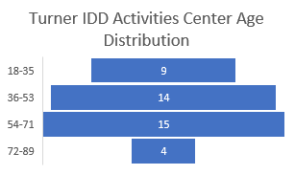

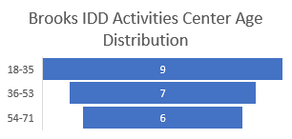

|  |  |
| --- | --- |
| **IDD Residential Group Home** |  |
| **Gender** |  |
| Male | 3 |
| **Race** |  |
| White/Caucasian | 2 |
| Black/African American | 1 |
| **Employment Status** |  |
| Retired/Disabled | 3 |
| **Age Distribution** |  |
| 18-35 | 1 |
| 36-53 | 1 |
| 54-71 | 1 |
| **Residential Status** |  |
| Supervised Housing - Rtf | 3 |

1. **OTHER CIRCUMSTANCES**

The current structure of the IDD Program was analyzed for efficiency and effectiveness in service delivery and financial sustainability. Positions of Program Managers at each Community Center were eliminated, and one Day Service Coordinator was put in place over the centers for a more uniform service in all locations. To increase and promote true community inclusion, two locations were identified at each end of the catchment area for physical Community Activity Centers. These two locations will serve as hubs for the community activities taking place throughout all the counties. Through efforts of the implemented IDD Advisory Council, individuals we serve expressed the importance of working in the community and getting back to their jobs. Pre-vocational services were reinstated in July of 2022.

Coordination has begun between the IDD Program and the BHCC staff to identify ways to best serve individuals with dual diagnosis of mental health and intellectual developmental disability. Individuals who present at the Crisis Center with an intellectual developmental disability diagnosis have unique and complex needs. IDD staff assists the BHCC clinicians with locating and requesting pertinent information on individuals diagnosed with IDD to better help clinicians effectively provide appropriate services.

**4. SUMMARY FINDINGS, RECOMMENDATIONS, AND ACTION PLAN**

**ACTIONS TAKEN FY22:**

* Revised organizational chart for IDD Day Services for efficient and financially sustainable program.
* Redefined the role of HST to Educational Activity Support Professional
* Revised Scope of Services for IDD Day and Residential Services
* Identified and completed several policies
* Resumed community access services in all counties, opening two physical sites for Day Services.
* Implemented an IDD Advisory Council
* Resumed Pre-Vocational Services
* Hired dedicated RN to provide nursing oversight to IDD Day Services.
* Received a 97% score on DBHDD QEPR audit.

**AREAS FOR IMPROVEMENT:**

* Create a standard of productivity for billing for direct care staff in IDD Day Services.
* Work with IT to improve forms to create an efficient way to pull reports for necessary data.
* Improve the training around health protocols for staff working with IDD individuals.
* Continue to improve and build upon the nursing services in IDD Day Services.
* Maximize the capability of the HRST Scoring to pull data and recommendations for conditions.
* Engage stakeholders in communication for quality feedback through outreach and organized meetings as the IDD Advisory Council

**COMPLETION OF ACTION PLAN FY22:**

* Assess current needs of the population in our community to determine need for additional group homes (Timeline: 12/01/2021) ***Pending***
* Assess current enrolled individuals to determine their choice of provider (Timeline 11/01/2021) ***Completed***
* Determine best ways to provide community integration whether through opening a physical day center or realigning to more complete integrated community activities (Timeline 11/01/2021) ***Completed***
* Review the need for new policies to be developed to better support services provided for individuals (Timeline: 02/01/2022) ***Completed***
* Review the Scope of Services with added details (Timeline 09/01/2021) ***Completed***
* Review the staff education plan (Timeline 11/01/2021) ***Completed***
* Redo the organizational structure for I/DD services (Timeline: 09/01/2021) ***Completed***

**ACTION PLAN FY23:**

* Establish productivity billing standard and accountability standards

(Timeframe: 09/1/2022)

* Improve electronic documentation by addicting care coordination with primary care provider and other annual appointments such as dental appointments to documentation with reporting capabilities (Timeframe: 12/1/2022)
* Engage minimum one stakeholder from each county on IDD Advisory Council (Timeframe: 06/1/2023)

**MEDICATION ASSISTED TREATMENT PROGRAM (MAT)/OFFICE -BASED OPIOID TREATMENT PROGRAM (OBOT)**

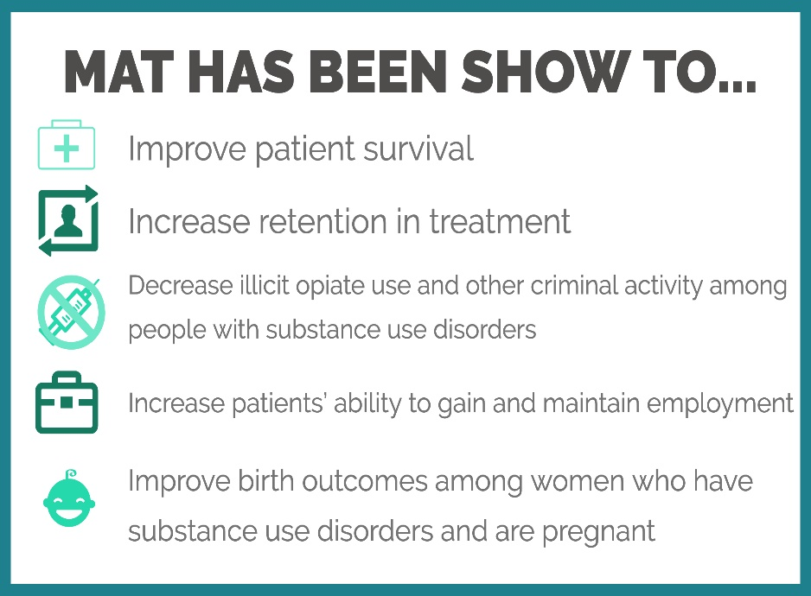Medication Assisted Treatment program provide specific interventions for reducing and /or elimination the use of illicit opioids and other drugs of abuse. MAT/OBOT is an outpatient program that uses medication, combination with counseling and behavioral therapies, to provide a “whole-person” approach to the treatment of substance use disorders. MAT is a multi-faceted approach treatment service for adults who required structure and support to achieve and maintain recovery from Opioid Use Disorders.

**MAT/OBOT**

**59**

**Persons Served First Year**

**1. RESULTS**

|  |  |  |  |
| --- | --- | --- | --- |
| ***MAT/OBOT Program Outcomes*** | | ***Target*** | ***Achieved*** |
| ***Effectiveness*** | 1) Number of reported medication errors 2) Reported Adverse Reactions | 1) 2 or less per month 2) 0 Occurrences | 1) 0 2) 0 |
|  | Individuals have access to medical medications if they were prescribed | 100% | 100% |
|  | % Of individuals employed 1) initially 2) currently | 1) 10% 2) 15% | 1) 41% 2) 35% |
|  | Reduce admissions to inpatient hospitals (medical hospital, CSU, psychiatric hospital) | <8% | 3% |
|  | Individuals continue program after relapse happens. Treatment plan addresses each possible relapse. 1) # /% of individuals who had relapse but continue MAT program. 2) #/% of treatment plans address the relapse/plan | 1) 60% 2) 100% | 1) 93% 2) 98.5% |
|  | COWS Scale is used each time medications are administered | 100% | 100% |
|  | Reduce the # of incarcerations/# of episodes individuals entered criminal justice system | 0/12 Months | 1/12 Months |
|  | Harm reduction education is done during the Nursing Intake. Education includes, but is not limited to 1) Overdose prevention education 2) Overdose reversal with Naloxone 3) Rescue breathing 4) Ensuring that individual have access to Naloxone | 100% | 92% |
| ***Efficiency*** | 1) Treatment team meetings are done minimum weekly with all participants (Clinician-Nurse-MD/APRN)  2) Progress/lack of progress and plan is clearly documented in medical records | 1) 100% 2) 100% | 1) 71% 2) 75% |
| ***Service Access*** | 1) Screening for MH services is offered when individual is not admitted to services/Those not admitted to program have been referred to appropriate services. 2) MH screening is completed | 1) 100% 2) 100% | 1) 100% 2) 100% |
| ***Satisfaction*** | Medication side effects are communicated effectively prior to medications are prescribed | 100% | 100% |
|  | Stakeholders are educated on LBHS MAT program and required screening process | Minimum 6 contacts per quarter | Avg 7 per quarter |
|  | Stakeholders report that the communication on LBHS MAT program was beneficial (Strongly Agree-Agree) | 90% Agree-Strongly Agree | 75% * Q4 not done Q1-3 100% |

**2. ANALYSIS OF CLIENT-SPECIFIC AND INFLUENCING FACTORS**

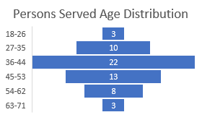

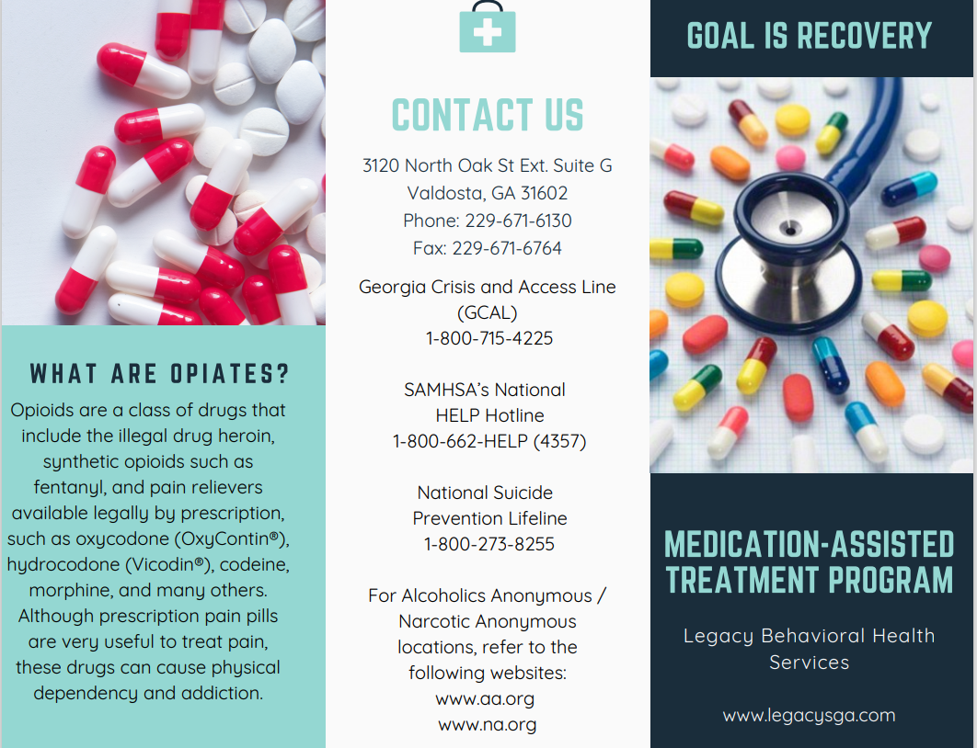

**3. OTHER CIRCUMSTANCES**

Opioid related overdose deaths have increased in Georgia by 245% between 2010 and 2017 according to Georgia Department of Public Health. The emergence of COVID-19, and the forced pause of normal routines, social experiences, careers, and healthy distractions, has caused the SUD and OUD challenges across rural Georgia to escalate both in scope and intensity. Recovered individuals are sliding into old habits with tremendous speed as their new routines and coping strategies are no longer effective.

The LBHS MAT/OBOT program opened in June 2021 and served 59 individuals its first year of operations. Hiring a staff with the experience on providing MAT/OBOT services was a challenge. Luckily, we were able to hire experienced RN as well as APRN with years of experience who were get this program started.

**4. SUMMARY FINDINGS, RECOMMENDATIONS, AND ACTION PLAN**

In accordance with regulatory requirements, multiple quality indicators were created to drive the quality outcomes of the program. Data collection for these indicators have been time consuming and labor intensive due to lack of automated reports. Care coordination internally and externally was one of the focus areas and we were able to implement effective care coordination documentation to improve communication across the LBHS services.

**FY22 ACTIONS TAKEN**

* Created initial quality indicators
* Hired experienced staff
* Developed extensive staff training program with competency-based assessments
* Implemented weekly meetings with the leadership team to quickly assess and implement administrative changed needed
* Created skills validation for all positions

**AREAS FOR IMPROVEMENT**

* Develop documentation templated to include indicators that are monitored in order to demonstrate quality services
* Employ CPS with the SUD background
* Develop a protocol for the CPS provided services
* Improve community education on availability and scope of MAT services
* Increase the number of persons served year two to 100 individuals
* Staff to get involved in NAMI chapters that is being initiated in our service area to offer additional resources

**COMPLETION OF ACTION PLAN FY22**

There was no formalized action plan for the FY22 since MAT/OBOT was not a part of the analysis year ago due to program being implemented in June 2021.

**ACTION PLAN FY23**

* Review and revise all documentation (Timeframe: 12/1/2022)
* Create meaningful electronic reports (Timeframe: 12/1/2022)
* Develop CPS protocols by (Timeframe: 10/1/2022)
* Employ CPS by (Timeframe: 11/1/2022)
* Get involved with local NAMI initiative (Timeframe: 9/1/2022)
* Improve community education with minimum 2 outreach activities per month (Timeframe: 9/1/2022)

**Projects for Assistance in Transitioning from Homelessness (PATH)**

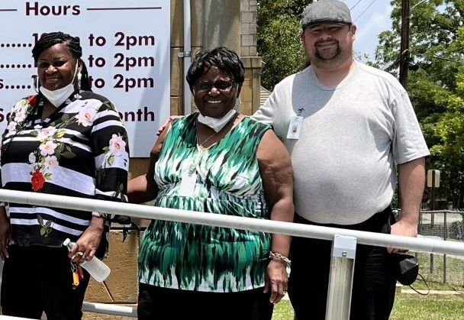Projects for Assistance in Transition from Homelessness (PATH) Program is part of the first major federal legislative response to homelessness. The PATH Program provides services to people with serious mental illness, including those with co-occurring substance use disorders, who are experiencing homelessness or at imminent risk of becoming homeless.

PATH serves anyone over the age of 18 that has a serious mental illness or co-occurring disorder and is either homeless or at imminent risk of becoming homeless within 14 days, with no place to live and no resources or support networks to obtain housing. Individuals served are also either unwilling or unable to seek services on their own, thereby necessitating those services being brought to them. Eligible individuals for services are those who are not in the guardianship of the State and do not receiving similar or duplicate State Behavioral Health Services. PATH can work with families; however, the individual being served must be an adult and head of household.

1. **RESULTS**

|  |  |  |  |
| --- | --- | --- | --- |
| ***PATH Program Outcomes*** | | ***Target*** | ***Achieved*** |
| ***Effectiveness*** | # Of outreaches done by PATH employees | 100% | 87% |
|  | Internal and external training and education done regarding PATH program. Once per month | 12/12 Months | 10/12 Months |
| ***Efficiency*** | % Of all enrolled individuals who have permanent housing at the time of discharge from PATH services | 50% | 46% |
| ***Service Access*** | % Of all active individuals enrolled with co-occurring conditions to SUD services | 40% or more | 56% |
|  | % Of total active individuals enrolled | 65% or more | 86% |
| ***Satisfaction*** | % Of all individuals enrolled rating satisfied/highly satisfied with linkage provided while enrolled on PATH program | ≥70% | 100% |
|  | % Of stakeholders rating satisfied/highly satisfied with referral process | ≥85% | 100% |

1. **ANALYSIS OF CLIENT-SPECIFIC EXTENUATING AND INFLUENCING FACTORS**

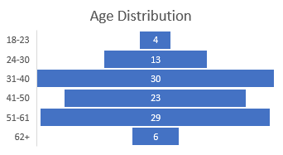

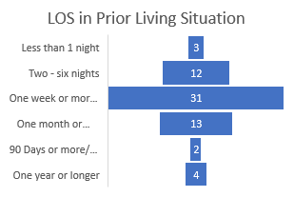

1. **OTHER CIRCUMSTANCES**

PATH program has increased their community outreach and awareness efforts by educating the community on the homeless programs and services they offer. Since many of the individuals who are experiencing homelessness also have co-occurring mental health and/or substance use disorder related conditions, we are fortunate to have our PATH program as a part of the organization who providers many services for MH/SUD related conditions. Employees at the PATH program provides expertise on assisting with the Need for Supporting Housing survey assessments when those are needed outside the PATH program.

**4. SUMMARY FINDINGS, RECOMMENDATION, AND ACTION PLAN**

**ACTIONS TAKEN FY22:**

* Created PATH Specific persons served satisfaction survey
* Improved community education efforts
* Established quality review and validation process with the external data
* Created departmental quality board
* PATH Team Leader became a member of Quality Council Committee
* Revised PATH Program brochure

**AREAS FOR IMPROVEMENT:**

* Increase outreach efforts outside the Lowndes County area
* Increase engagement and SUD service referrals to those individuals who have SUD related conditions
* Increase overall enrollment into permanent housing

**COMPLETION OF ACTION PLAN FY22:**

* Revise PATH specific brochure (Timeline 10/1/2021) ***Completed***
* Create PATH specific satisfaction survey (Timeline 10/30/2021) ***Completed***
* Have finalized MOUs with community partners (Timeline 3/30/2022) ***Ongoing***
* Enroll PATH individuals to Avatar EMR to collect demographic data and enrollment specific data (Timeline 3/20/2022) ***Ongoing***
* Improve engagement with individuals served to follow up with the referrals made to MH and SUD services (Timeline 1/30/2022) ***Completed***
* Increase the number of outreaches done (Timeframe 9/30/2021) ***Completed***
* Establish a contact list for all shelters and food pantries within LBHS 10-county service area (Timeframe 1/30/2022) ***Completed***

**ACTION PLAN FY23:**

* Have finalized MOUs with community partners (Timeframe: 3/1/2023)
* Enroll PATH individuals to Avatar EMR to collect demographic data and enrollment specific data (Timeframe: 3/1/2023)
* Improve engagement with individuals served to follow up with the referrals made to MH and SUD services (Timeframe: 2/1/2023)
* Work with the clinical team to establish a policy for the NSH Survey (Timeframe: 09/01/22)

**RESIDENTIAL SERVICES**

LBHS offers multiple levels of residential programs and services. The variety and availability of Residential services is a vital part of the LBHS continuum of care services offered. An advantage of multiple residential programs with several different levels allows persons served to move within an integrated system while working towards independence and improved quality of life. The Social Determinants of Health are addressed by residential staff in an effort to remove barriers preventing a balanced life which includes promoting mental health, overall wellness, and disease prevention.

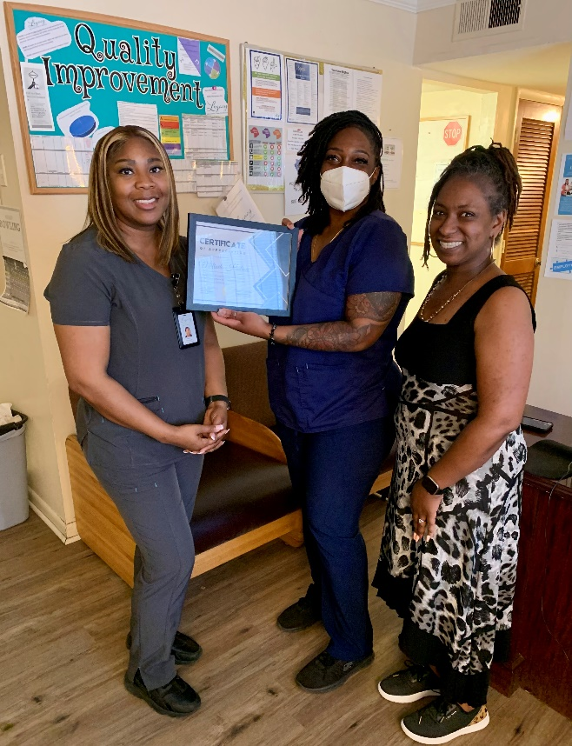 **LBHS RESIDENTIAL AND HOUSING PROGRAMS:**

**֍ COMMUNITY RESIDENTIAL REHABILITATION**

**(SEMI INDEPENDENT/LEVEL 1)**

* Heritage -6 beds
* Brooks ITR - 4 beds
* Midtown -10 beds
* New Heights -14 beds
* New Outlook Forensic -14 beds

**֍ INDEPENDENT AD PROGRAM**

* Beacon of Hope -10 beds

**֍ CRISIS RESPITE APARTMENTS**

* 1300 Iola - 4 beds
* Lemans -2 beds

**֍ SEMI-INDEPENDENT AD PROGRAM**

* START -10 beds

**֍ COMMUNITY RESIDENTIAL REHABILITATION III (SEMI-INDEPENDENT/LEVEL 3)**

* Bridge (6 beds)

**֍ PERMANENT SUPPORTED HOUSING (GHVP)**

* About 300 individuals
* 24-counties

**֍ GRADUATE/GHFA-PSH (The Georgia Housing & Finance Authority-Permanent Supportive Housing)**

formerly known as Shelter Plus Care

* Graduate -12 beds (included in 111)
* About 111 individuals

**֍ PRIVATE HOME CARE** (License for Service)

* Midtown-10 beds
* New Heights-14 beds

**֍ COMMUNITY LIVING ARRANGEMENT (License for Service)**

* Brooks ITR – 4 beds
* Heritage – 6 beds

**֍ COMMUNITY RESIDENTIAL REHABILITATION (Semi-Independent Short Term)**

* Uptown Living -6 beds

**֍ GRADUATE/GHFA-PSH (The Georgia Housing & Finance Authority-Permanent Supportive Housing)**

The GHFA Permanent Supportive Housing (PSH) program provides permanent housing in connection with supportive services to persons who have a disability and are experiencing homelessness. The program provides rental assistance funded by the Department of Housing and Urban Development (HUD), accompanied by a range of supportive services funded by other sources. The GHFA PSH Program is designed to serve a population that has been traditionally hard to reach – homeless persons with disabilities such as (but not limited to) serious mental illness, chronic substance abuse, and/or AIDS and related diseases. This program is built on the best practices that housing and services should be connected in order to ensure stability for this population. Consequently, GHFA PSH provides rental assistance that local subgrantees much match, with supportive services appropriate to the target population. The goals of the GHFA PSH Program are to assist homeless individuals and their families to increase their housing stability, skills and /or income, and self-sufficiency.

The Graduate Program is a Georgia state funded grant program and GHFA PSH is a federally funded grant program. In addition to housing, supportive services are provided to all individuals in these programs by Legacy BHS according to the needs of the persons served. The need for housing support for this population is overwhelming and exceeds the current contracted number of units.

1. **RESULTS**

|  |  |  |  |
| --- | --- | --- | --- |
| ***Program Outcomes*** | | ***Target*** | ***Achieved*** |
| ***Effectiveness*** | Persons served will be able to maintain permanent housing | 80% | 96% |
| ***Efficiency*** | Total billable PSRI/CM/ADSS Hours for FT 65 Hrs./month & PT 35 Hrs./month | 100% | 100% |
| ***Service Access*** | Bed Utilization - # of contract beds vs beds utilized | 100% | 112% |
| ***Satisfaction*** | % Of persons served expressing satisfaction with services provided | 80% | 91% |
|  | % Of stakeholders satisfied with service access and benefit to consumers | 80% | 96% |

1. **ANALYSIS OF CLIENT-SPECIFIC EXTENUATING AND INFLUENCING FACTORS**

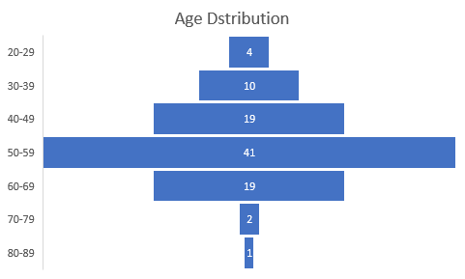

The need to provide housing for qualified individuals is overwhelming. Contract agreements provide funding for 68 apartments (1/2/3-bedroom units) with the actual end of the year occupancy rate being 76 apartments.

1. **OTHER CIRCUMSTANCES**

Legacy BHS is committed to improving the housing situation for those who meet the program requirements but recognizes that it needs to be done in accordance with allocated resources in order to maintain financial stability of all programs.

**4. SUMMARY FINDINGS, RECOMMENDATIONS AND ACTION PLAN**

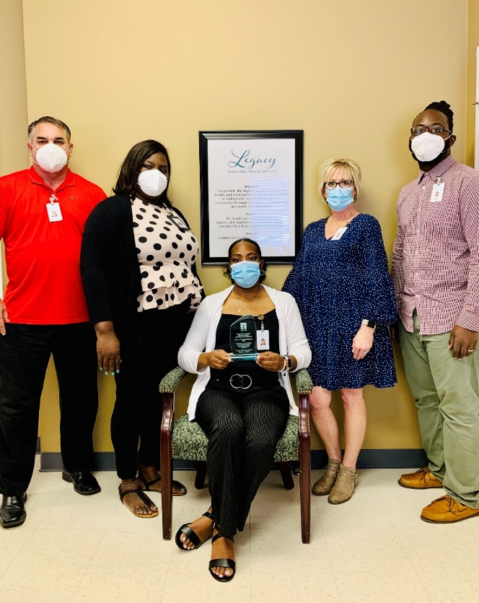By utilizing wrap-around services and support, 96% of individuals served by GHFA PSH were successful in maintaining permanent housing. Community referrals as well as internal organizational referrals for housing continues to exceed current capacity. Potential partnerships with community partners such as Housing Choice Voucher, Georgia Housing Voucher, Section811 Supportive Housing for Persons with Disabilities Program, and private landlords (for consumers who have income and can both afford and manage independent living) provide alternative avenues in locating additional housing. In addition, we continue serving as community advocates to improve the lack of housing availability and reduce the stigma of mental illness.

Co-operation with BHCC discharge planners and organizational case managers are some of the continued areas of focus. Residential staff continues to work on improving the individuals’ sense of hope for the future and assisting them in understanding the benefits of improving life skills and their connection to overall quality of life, while also assisting individuals in adjusting to living with changes caused by the pandemic which has impacted their everyday lives.

This program met all quality indicators and served more individuals as expected by the DBHDD contract. However, that was done within the expected budget.

**֍ Community Residential Rehabilitation (Intensive/Level 1) - New Outlook** **Forensic, Midtown, Heritage, New Heights, Brooks ITR**

The majority of the persons served on these programs have a long history of severe mental illness, with co-occurring conditions including addictive disease as well as some with intellectual and developmental disorders. Many of the individuals served at the residential sites have a history of multiple psychiatric admissions to state hospitals as well as Crisis Stabilization Units and private psychiatric hospitals. In addition, Individuals prior to admission into the New Outlook program have spent several years in the forensic programs. Program goals are set based on each person’s individualized needs with focus to prepare them to live in community settings as independently as possible. However, many residents lack daily living skills needed to maintain independent living. In addition, many of them are reluctant to change due to fear of the future, even with improved skills to manage their personal affairs. Medication management is a major factor which increases the length of stay at these residential programs.

1. **RESULTS**

|  |  |  |  |  |  |  |  |
| --- | --- | --- | --- | --- | --- | --- | --- |
| ***Program Outcomes*** | | ***Target*** | ***New Outlook Forensic Achieved*** | ***Midtown Achieved*** | ***Heritage Achieved*** | ***New Heights Achieved*** | ***Brooks ITR Achieved*** |
| ***Effectiveness*** | % Of individuals who follow the recommendation from treatment team to attend services such as PSS, Individual services, group services etc. | 80% | 100% | 96% | N/A | 51% | N/A |
|  | % Of persons served will remain free from psychiatric hospitalizations | 90% | N/A | N/A | 98% | N/A | 100% |
|  | # Of negative UDS/ # of total random and targeted UDS done | 90% | 91% | N/A | N/A | 75.00% | N/A |
|  | % Of consumers not utilizing EMT's for non-emergency medical services | 90% | N/A | N/A | 95.80% | N/A | 100% |
|  | Individuals call EMT services only for medical emergencies | 90% | N/A | N/A | 96% | N/A | 100% |
|  | Actual Average LOS | <18 Months | 18.8 Months | 16 Months | 23 Months | 14 Months | 14 Months |
| ***Efficiency*** | Total billable PSRI/CM Hours for FT 30 Hrs/month & PT 18 Hrs/month or Total billable | 100% | 91% | 99.50% | 100% | 76% | 76% |
|  | Bed Utilization - % of occupancy | 90% | 42% | 90% | 61% | 84% | 90% |
| ***Service Access*** | % Of individuals referred vs accepted to programs | 70% | 100% | 50% | 66% | 63% | 100% |
| ***Satisfaction*** | % Of persons served expressing satisfaction with services provided | 80% | 89% | 89% | 89% | 89% | 89% |
|  | % Of stakeholders satisfied with service access and benefit to consumers | 80% | 96% | 96% | 96% | 96% | 96% |

1. **ANALYSIS OF CLIENT-SPECIFIC EXTENUATING AND INFLUENCING FACTORS**

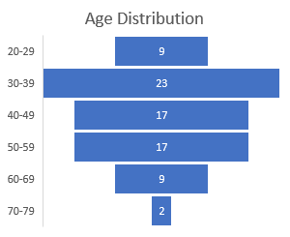

1. **OTHER CIRCUMSTANCES**

At the New Outlook program, the courts must approve individual to move onto independent living.

During the FY22, more individuals were completing programs than any previous years. Individuals were moved to voucher programs or other appropriate placements.

Finally, a lack of qualified and motivated candidates for open staffing positions due to the ongoing nation-wide labor shortage, continues to be barrier to stabilize residential staffing. Lack of staffing has also affected programs not being able to operate on their maximum capacity. Adequate staffing is essential for LBHS and individual programs to ensure safety.

The ongoing COVID-19 pandemic has created many additional challenges with many residents experiencing increased fear and uncertainty of the future, including social isolation. In addition, the ongoing use of alcohol or/and other substances by individuals remains an ongoing barrier to achieving persons served specific outcomes and the ability to move towards independent living and improved life conditions. An additional challenge is the overall lack of affordable housing options with the significant rent increases during the FY22.

**4. SUMMARY FINDINGS, RECOMMENDATIONS AND ACTION PLAN**

Hospital admissions were prevented entirely during the first 11 months of FY22. Also, timeliness to complete the programs has increased significantly, leaving Heritage program LOS being outside the expected 18-month timeframe until the last month of FY22.

In order to successfully decrease the LOS is one of the key functions these programs. Coordinated visits, family involvement, and daily support will decrease fears of living independently.

Legacy BHS residential programs with leadership continues to work on advocating for individuals with severe mental illness and addictive diseases. Some of the overall goals include the following:

* Participation in state level advocacy and resource collaboration to assist individual in living independently in community settings with wrap around services such as ACT, Case Management, Certified Peer Specialist (CPS) Services an array of OP Groups and individual therapy, Supported Employment, Vocational Rehabilitation, Community Based Volunteer Work and more.
* Provision of community level education to promote natural support and build confidence and trust.
* Ongoing staff recruitment, training, and retention efforts to ensure that staff vacancies are minimized, and educational training is completed in a timely manner in order to improve the lives of those we serve.
* Multiple Career Fairs
* Staff recruitment on social media as well as with local University, Technical Colleges, with Managers/Director visiting all Social Science classes to promote the need for staff.

Bed Utilization was area that wasn’t met for all the CRR Level I Programs

* Vacant positions are one of the reasons why all available beds could not be used.
* Continued pandemic COVID-19 was still prevalent during the beginning of the fiscal year and the ability to admit was hindered.

Staff meeting the efficiency expectation on providing services was another area that did not meet the expected target goals.

**֍ Residential Community Rehabilitation (Semi-Independent/Level III)- BRIDGE**

Community Residential Rehabilitation III (CRR III) provides rehabilitative skills building, acquisition and training in activities of daily living, home and personal management, community integration activities and rehabilitative supervision in residential setting. Bridge program provides a program of residential rehabilitation services to an individual who requires moderate and periodic support of structured residential interventions to achieve/enhance their recovery/wellness, increase self-sufficiency, independency, and community integration. LBHS Bridge Residential Program first opened in February 2021, with capacity of six (6) beds.

1. **RESULTS**

|  |  |  |  |
| --- | --- | --- | --- |
| ***Program Outcomes*** | | ***Target*** | ***Bridge Achieved*** |
| ***Effectiveness*** | # Of negative UDS/ # of total random and targeted UDS done | 85% | 79% |
|  | Average LOS | <18 Months | 8.3 Months |
| ***Efficiency*** | Total billable PSRI/CM Hours for FT 30 Hrs/month & PT 15 Hrs/month | 100% | 98% |
|  | Bed Utilization - % of occupancy | 90% | 78% |
| ***Service Access*** | % Of individuals referred vs accepted to programs | 70% | 67% |
| ***Satisfaction*** | % Of persons served expressing satisfaction with services provided | 80% | 91% |
|  | % Of stakeholders satisfied with service access and benefit to consumers | 80% | 96% |

1. **ANALYSIS OF CLIENT-SPECIFIC EXTENUATING AND INFLUENCING FACTORS**

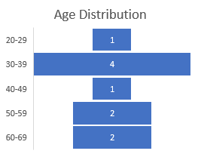

1. **OTHER CIRCUMSTANCES**

During the FY22, the Bridge programs increased the number of random urine drug testing, in addition to targeted drug testing. 21% of tests performed resulted in positive results. After one year of operation, the longest LOS was approximately 9 months, and the bed utilization has varied between 50-95%.

**4. SUMMARY FINDINGS, RECOMMENDATIONS AND ACTION PLAN**

This program will need increased referrals in order to keep the beds occupied. During the FY22, the program received total of 7 referrals with 4 of those meeting actual program requirements. Additional community education and maintaining staffing at the required level will improve opportunities to keep the program at its full capacity.

**֍ INDEPENDENT AD RESIDENTIAL SERVICES- Beacon of Hope**

Beacon of Hope Is an addictive diseases independent residential program that provides a structured therapeutic environment that is a safe, stable, drug free residence, designed to facilitate the progress of individuals with a substance use disorder (SUD) towards recovery. This program must coincide with Addictive Diseases (AD) Outpatient (OP) services. Therefore, involvement in treatment prior to applying for this service is a requirement. The length of stay can be up to 12 months as clinically appropriate.

This program setting is less restrictive with reduced supervision, as individuals begin to strengthen and focus on gaining/ improving life skills, vocational/educational skills, work habits, and on creating financial, environmental, and social stability to increase the probability of long-term recovery. All residents are expected to be employed within a month of admission to the program. Transportation is provided to and from work, group meetings, doctor and therapy appointments, shopping, academics, recreational and other support activities.

The Graduate Program is a Georgia state funded grant program and GHFA PSH is a federally funded grant program. In addition to housing, supportive services are provided to all individuals in these programs by Legacy BHS according to the needs of the persons served. The need for housing support for this population is overwhelming and exceeds the current contracted number of units.

**1. RESULTS**

|  |  |  |  |
| --- | --- | --- | --- |
| ***Program Outcomes*** | | ***Target*** | ***Beacon of Hope Achieved*** |
| ***Effectiveness*** | Persons served demonstrate fiscal responsibility | 95% | 92% |
|  | # Of negative UDS/ # of total random and targeted UDS done | 90% | 97% |
|  | % Of individuals will follow their treatment plan to attend the scheduled weekly group sessions | 100% | 100% |
|  | % Of individuals who obtain employment within 2 weeks of admission to program | 90% | 100% |
| ***Efficiency*** | Total of 5 billable ADSS Hours/week/each staff | 100% | 81% |
|  | Bed Utilization - % of occupancy | 90% | 69.30% |
| ***Service Access*** | % Of individuals referred vs accepted to programs | 70% | 64% |
| ***Satisfaction*** | % Of consumers expressing satisfaction with services provided | 80% | 91% |
|  | % Of stakeholders satisfied with service access and benefit to consumers | 80% | 96% |

**2. ANALYSIS OF CLIENT-SPECIFIC EXENUATING AND INFLUENCING FACTORS**

Residential staff provides transportation on all shifts to and from daily meetings, doctor and therapy appointments, shopping, academics, job related, recreational and other support activities. Without transportation assistance, it would be difficult for these individuals to practice community integration and move towards independent living. Social isolation and pandemic related restrictions have negatively impacted individuals for these programs due to less opportunities for employment and recreational activities.

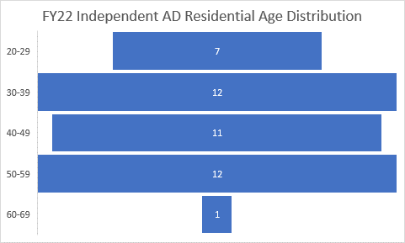

**3. OTHER CIRCUMSTANCES**

Co-operation with the OP clinics, Crisis Center, Peer Program, and referral sources are important factors for a successful stay. Improved communication and co-operation with drug courts and judicial systems, with a stable leadership team have made transitions of care less fragmented. Peer services are offered on-site. Improved communication of service availability throughout the state of Georgia is also expected to improve bed utilization. On the other hand, those individuals who would benefit from these types of services often have financial obligations and therefore tend to defer the services. Lack of a stable natural support system to encourage the individuals’ wellness and health is often lacking. In addition, individuals who have private insurance are not qualified to participate in the programs.

At the beginning of the pandemic the normal process for receiving referrals was interrupted. Several residents also lost their jobs due to employment layoffs resulting from the COVID-19 pandemic, however, during FY22 employment increased.

Less restricted pandemic requirements have allowed individuals to return to groups therapy which has helped to keep our individuals in recovery and decreased substance use.

**4. SUMMARY FINDINGS, RECOMMENDATIONS AND ACTION PLAN**

Individuals at the Beacon of Hope program averaged 92% success rate in paying their rents, and based on random and targeted UDS, were 97% drug free. Employment increased during the past year compared to FY21. The Beacon of Hope Program capacity is 10, with an average occupancy rate of 69%.

Efforts continue in regard to educating community members and stakeholders on program admission criteria as referrals often cannot be accepted due to the severity of individuals underlying medical issues. Since semi-independent living arrangements require individuals to be able to care for themselves, those with significant medical issues are not able to meet the admission criteria.

**֍ CRISIS RESPITE APARTMENTS**

Crisis Respite Program is designed for individuals who need a temporary placement only. The capacity of this program is 6 beds. Individuals are encouraged to attend one of the day programs and or groups offered by LBHS, as well as being compliance with all other areas of the residential program as well as other treatment requirements. Individuals receiving this service should be capable of living independently as well as capable of taking their medications as prescribed.

1. **RESULTS**

|  |  |  |  |
| --- | --- | --- | --- |
| ***Program Outcomes*** | | ***Target*** | ***Crisis Respite Apartment Achieved*** |
| ***Effectiveness*** | Average LOS | 30 Days | 26 Days |
|  | # Of housing searches | 3 Per Week | Avg 2 Per Week |
| ***Efficiency*** | % Of person served will be linked to a housing specialist within 2 days of admission | 100% | 100% |
|  | Minimum of 2 contacts per day | 70% | 75% |
|  | Bed Utilization - % of occupancy | 90% | 47% |
| ***Service Access*** | % Of individuals referred vs accepted to programs | 70% | 93% |
| ***Satisfaction*** | % Of persons served expressing satisfaction with services provided | 80% | 91% |
|  | % Of stakeholders satisfied with service access and benefit to person served | 80% | 96% |

1. **ANALYSIS OF CLIENT-SPECIFIC AND INFLUENCING FACTORS**

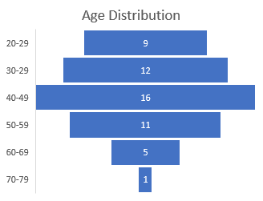

1. **OTHER CIRCUMSTANCES**

Relocation of the program in the middle of the fiscal year caused some issues on bed utilization. However, this move has been positive due to improved relationship created with the landlord. Service provision will also improve with the ability to fill open positions. Placing this program directly under our Housing Program has also helped to move individuals onto the appropriate living situation in a timely manner.

**4. SUMMARY FINDINGS, RECOMMENDATIONS AND ACTION PLAN**

LOS for this program is maximum 30 days, and during FY22 the average LOS varied from 19 to 30 days. Housing options after the program completion however are limited however, due to lack of affordable housing with cost of rents increasing significantly during FY22. All individuals were linked with the housing specialist within 2 days of admission. 75% of individuals in this program received a minimum of 2 contacts per day by residential staff. The annual average occupancy rate of this service is only 47% primarily due to staffing shortages and lack of referrals. During FY22, 93% of all referrals received were able to be admitted to the program.

**֍ PERMANENT SUPPORTED HOUSING (GHVP)**

The Georgia Housing Voucher program (GHVP) provides permanent supportive housing to individuals with mental illness. The program focuses on chronically homeless individuals as well as those transitioning out of state psychiatric institutions. In addition to rental support, voucher recipients are eligible for bridge funding that covers security deposits and moving expenses.

**1. RESULTS**

|  |  |  |  |
| --- | --- | --- | --- |
| ***Program Outcomes*** | | ***Target*** | ***GHVP Achieved*** |
| ***Effectiveness*** | % Of consumers will remain free from psychiatric hospitalizations | 90% | 92% |
|  | % Of consumers will remain free from incarceration | 90% | 97% |
|  | % Of consumers will maintain permanent housing once received | 90% | 96% |
| ***Efficiency*** | An initial individualized treatment plan is completed, and intervention are planned according to EBP based on assessment findings and Treatment plan is updated timely | 100% | 100% |
|  | All GHVP individuals will receive two Wellness Housing Support checks per month and Identified "Most in Need" Individuals will receive 3 or more per month | 100% | 100% |
|  | Encounters are done face-to-face | 50% | 98% |
|  | Services are provided at the homes of persons served | 80% | 86% |
|  | Each individual will have a choices of available unit/housing options | 100% | 100% |
| ***Service Access*** | Communication with landlords is done monthly via telephone and quarterly face-to-face. | 100% | 100% |
| ***Satisfaction*** | % Of persons served expressing satisfaction with services provided | 85% | 91% |
|  | % Of stakeholders satisfied with service access and benefit to persons served | 90% | 96% |

**2. ANALYSIS OF CLIENT-SPECIFIC AND INFLUENCING FACTORS**

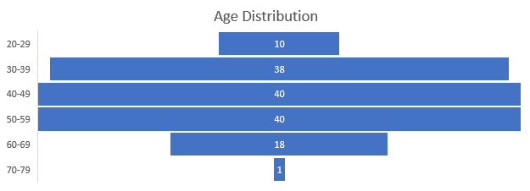

**3. OTHER CIRCUMSTANCES**

The contract to cover all 24 counties started on August 2021. However, there was much time spend on hiring staff and transferring needed documents to our EMR.

Successfully improving communication with landlords has resulted in improved access to affordable housing. However significant increase in rental prices has limited available options. Program goals include facilitation of permanent housing for individuals in need who have a severe and persistent mental illness, in order to prevent homelessness and promote independence and long-term recovery. It is crucial that this be done in collaboration with other care providers and community partners in order to successfully reduce homelessness for those who are vulnerable.

**4. SUMMARY FINDINGS, RECOMMENDATIONS AND ACTION PLAN**

During FY22, all of targeted outcome results were achieved. Only 8% of individual experienced psychiatric hospitalizations compared to 14% in FY21.

Incarcerations also decreased from 5% in FY21 to 3% in FY22. 96% of individuals were able to maintain permanent housing once it was obtained. This percentage remained unchanged from the previous year. 100% of individuals were offered choices of housing options.

Outcomes for the additional individuals served at the “new” 14 counties were not collected since the data was not fully available. This addition of counties served has increased the need of recruitment of additional landlords.

**֍ SEMI-INDEPENDENT AD PROGRAM- START**

START Addictive Diseases Program is a semi-independent residential living program operating with the same principles as Beacon of Hope program. Some of the staff duties may include assisting individuals in the development of goals for engaging in personal recovery plans, including the negative impact of substances, and developing skills to prevent possible relapses. Assistance can also include, but is not limited, to individuals attending daily OP group treatment, attending at least 3 AA/NA/CR meetings weekly, finding a sponsor and developing a recovery-oriented relationship, engagement in activities of daily living, and coordinating after care plans/programs including safe housing upon discharge. Staff is available for individuals 24 hours a day/7 day a week.

**1. RESULTS**

|  |  |  |  |
| --- | --- | --- | --- |
| ***Program Outcomes*** | | ***Target*** | ***START Achieved*** |
| ***Effectiveness*** | # Of negative UDS/# of total random and targeted UDS done | 90% | 93% |
| ***Efficiency*** | 5 Billable ADSS hours/week/each staff | 100% | 81% |
|  | Bed Utilization - % of occupancy | 90% | 53% |
| ***Service Access*** | % Of individuals accepted vs referred to programs | 70% | 51% |
| ***Satisfaction*** | % Of persons served expressing satisfaction with services provided | 85% | 91% |
|  | % Of stakeholders satisfied with service access and benefit to persons served | 90% | 96% |

**2. ANALYSIS OF CLIENT-SPECIFIC AND INFLUENCING FACTORS**

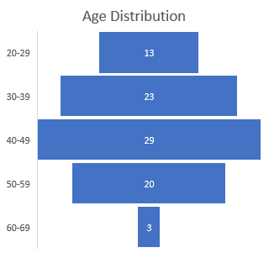

**3. OTHER CIRCUMSTANCES**

At the beginning of the pandemic the normal process for receiving referrals was interrupted. Several residents lost their jobs due to layoffs resulting from the pandemic. Throughout the pandemic, LBHS continued to provide care and treatments at the OP clinics, Crisis Center and to make referrals to meet the needs of the individuals served with their whole health in mind.

**4. SUMMARY FINDINGS, RECOMMENDATIONS AND ACTION PLAN**

START program operated with 53% occupancy during FY22, compared to 78% occupancy on FY21. 7% of random and targeted drug screenings resulted in positive results, compared to 1% in FY21. Many referrals made to the START program do not result in actual admissions, which was reflected in the past years’ conversion rate of 51%. Some referrals did not meet criteria, since some individuals who needed detox prior to admission, did not agree to go to detox. Also, staff efficiency was below the expectation, as only 81% of staff time was spend providing billable services 5 hours per week.

**֍ Private Home Care (PHC)**

The Department of Community Health, Healthcare Facility Regulation (HFR) gives a license for the services provided at the Midtown, and New Heights with a Private Home Care license. Under this license LBHS provides Companion Sitter services which means the following services are offered, transport and escort services; meal preparation and serving; and household tasks essential to cleanliness and safety.

**1. RESULTS**

|  |  |  |  |
| --- | --- | --- | --- |
| ***Program Outcomes*** | | ***Target*** | ***PHC Achieved*** |
| ***Efficiency*** | % Of completion of Service Plan and Service Agreement | 100% | 100% |
|  | % Of completion of the Task Sheet | 100% | 100% |
|  | % Of completion of the Supervisory Visit | 100% | 100% |
| ***Satisfaction*** | % Of persons served expressing satisfaction with services provided | 85% | 91% |
|  | % Of stakeholders satisfied with service access and benefit to persons served | 90% | 96% |

**2. ANALYSIS OF CLIENT-SPECIFIC AND INFLUENCING FACTORS**

Refer to Analysis on Community Residential Rehabilitation (Intensive/Level 1)

**3. OTHER CIRCUMSTANCES**

One of the fucus areas has been the infection control and cleanliness to prevent the spread of

COVID-19 pandemic. Ongoing education has decreased fears of person served to return to community

activities.

**4. SUMMARY FINDINGS, RECOMMENDATIONS AND ACTION PLAN**

. PHC met all quality indicators this past year.

**֍ COMMUNITY LIVING ARRANGEMENT**

The Department of Community Health Healthcare Facility Regulation licenses Brooks ITR and Heritage Group Homes as a Community Living Arrangement. This license is to provide or arrange for the provision of daily personal services, supports, care, or treatment exclusively for two or more adults who are not related to the owner or administrator by blood or marriage and whose residential services are financially supported, in whole or in part, by funds designated through the Department of Human Resources, Division of Mental Health, Developmental Disabilities, and Addictive Diseases.

**1. RESULTS**

|  |  |  |  |
| --- | --- | --- | --- |
| ***Program Outcomes*** | | ***Target*** | ***CLA Achieved*** |
| ***Efficiency*** | % Of completion - Admission Agreement | 100% | 100% |
|  | Physician's Report - % of completion prior to admission | 100% | 100% |
|  | Primary Care Provider - % of consumers establishing PCP | 100% | 100% |
| ***Satisfaction*** | % Of persons served expressing satisfaction with services provided | 85% | 91% |
|  | % Of stakeholders satisfied with service access and benefit to person served | 90% | 96% |

**2. ANALYSIS OF CLIENT-SPECIFIC AND INFLUENCING FACTORS**

Refer to Analysis of Community Residential Rehabilitation (Intensive/Level 1)

**3. OTHER CIRCUMSTANCES**

One of the fucus areas has been decreasing fears of person served to return community

activities.

**4. SUMMARY FINDINGS, RECOMMENDATIONS AND ACTION PLAN**

Community Living Arrangement Program met all quality indicators set for the FY22.

**֍ Community Residential Rehabilitation (Semi-Independent Short Term) - Uptown Living**

Uptown Living is a short-term transitional residential program that provides transitional services for adults with a Severe and Persistent Mental Illness (SPMI) and who are discharging from a psychiatric hospitals and crisis units. This level of transitional residential support requires 23/7 awake staff. Transitional program provides short term treatment supports with LOS 6-9 months. This is a new program with the initial contract signed October 2021.

**1. RESULTS**

|  |  |  |  |
| --- | --- | --- | --- |
| ***Program Outcomes*** | | ***Target*** | ***Uptown Living Achieved*** |
| ***Effectiveness*** | % Of individuals who follow the recommendation from treatment team to attend services such as PSS, Individual services, group services etc. | 80% | 100% |
|  | Average LOS | <9 Months | 1.1 Months |
| ***Efficiency*** | Total billable PSRI/CM Hours for FT 30 Hrs/month & PT 18 Hrs/month | 100% | 99% |
|  | Bed Utilization - % of occupancy | 90% | 32% |
| ***Service Access*** | % Of individuals referred vs accepted to programs | 70% | 100% |
| ***Satisfaction*** | % Of persons served expressing satisfaction with services provided | 80% | 91% |
|  | % Of stakeholders satisfied with service access and benefit to persons served | 80% | 96% |

**2. ANALYSIS OF CLIENT-SPECIFIC AND INFLUENCING FACTORS**

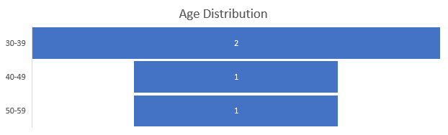

**3. OTHER CIRCUMSTANCES**

Staffing shortages to get this program fully implemented has presented quite a challenge. As a results, the program has only been able to maintain the census of 3 during FY22. The plan is to move this program to a permanent location during FY23.

**4. SUMMARY FINDINGS, RECOMMENDATIONS AND ACTION PLAN**

This is a new program that has been operating only since October 2021. Program has a total of 6 beds

but has only been operating with 50% capacity since opening. Once the program is able to increase

its occupancy rate, we will be able to measure quality indictors with increased validity.

**RESIDENTIAL AND HOUSING PROGRAMS**

**ACTIONS TAKEN FY22:**

* A market rate analysis was completed on residential direct care staff and salaries were brought up to market rate
* Georgia Housing Voucher (GHVP) received high marks for the Fidelity Monitoring Review.
* Received high marks from the Department of Community Health Healthcare Facility Regulation Private Home Care Audit.
* Received 0 deficiencies from the Department of Community Affairs Georgia Housing Finance Authority/Permanent Supported Housing Audit.
* Crisis Respite Apartment received high remarks on the June 2022 ASO Audit.
* Reduced the LOS for individual at the Crisis Respite Apartment to less than 30 days.
* Received the Region 4 Housing Support Provider Contract for 24 counties, serving 300 individuals.
* Filled 90% of Housing Support Positions to include a full time Licensed Therapist.
* Improved partnerships with the Region 4 Core Providers to ensure the success of the Region Housing Support Program.
* Developed positive relationships with statewide Housing Support providers, Region Field Offices and The Office of Supportive Housing.
* Relocated Crisis Respite Apartment to improve living conditions and location
* Implemented an electronic Functional Analysis Assessment to determine readiness for individuals to transition to more independent living
* Improved electronic reporting capabilities
* Continued the promotion of same day documentation practices
* Utilized telehealth daily with OP and PCP providers to promote access to care

**AREAS FOR IMPROVEMENT:**

* Continue to work closely with Human Resources and LBHS leadership team to promote staff recruitment and retention efforts.
* Work to train new staff efficiently and effectively to improve onboarding.
* Implement mentoring program
* Continue to improve staff efficiency regarding documentation
* Continue to work towards moving all documentation to EMR
* Review promotional material for the Residential services.
* Continue staff education and information as well as person served education and communication on infection control measures.

**COMPLETION OF ACTION PLAN FY22:**

* Open new Regional Housing Support Program if grant proposal is approved (Timeframe: 10/2021). ***Completed***
* Work towards moving all documentation to EMR with elimination of paper forms (Timeframe: 05/2022). ***Not Achieved***
* Work with HR to implement and maintain weekly open interviews with same day job offers until all positions are filled (Timeframe: 11/2021). ***Completed***
* Establish a staff retention plan in conjunction with HR (Timeframe: 11/2021). ***Not Achieved***
* Review established staffing patterns and schedules (Timeframe: 10/2021). ***Completed***
* Implement new staff residential training plan (initial and ongoing) to promote retention and improve overall quality of care (Timeframe: 12/2021).***Completed***
* Implement a plan to improve consumer engagement (Timeframe: 01/2022). ***Ongoing***
* Increase meaningful referral by marketing efforts and stakeholder education (Timeframe: 09/2021). ***Ongoing***
* Work with landlords on additional housing projects (Timeframe: 11/2021). ***Completed***
* Assign a Housing Specialist to Crisis Respite Apartment to work on housing and timely transition of care efforts (Timeframe: 11/2021). ***Completed***
* Create additional electronic reports to manage and monitor consumer care more effectively in real time (Timeframe: 06/2022). ***Completed***
* Work towards improvement of Care Coordination throughout the agency by working with the Care Coordination workgroup and reporting to the clinical team (Timeframe: 11/2021). ***Ongoing***

**ACTION PLAN FY23:**

* Complete all necessary requirements for the Housing Support Program in 24 county area (Timeframe: 11/1/2022).
* Work towards moving all documentation to EMR with elimination of paper forms (Timeframe: 05/1/2023).
* Establish a staff retention plan in conjunction with HR (Timeframe: 1/1/2023).
* Continue to work towards improvement of Care Coordination throughout the agency by working with the Care Coordination workgroup and reporting to the clinical team (Timeframe: 2/1/2023).
* Work diligently with DBHDD to improve state referrals. (Timeframe:1/1/2023)
* Partner with certain Landlords on housing projects. (Timeframe:3/1/2023)
* Initiate Re-Entry Program with 6 bed capacity. (Timeframe: 8/1/2022)
* Relocate the Uptown Living Program (Timeframe: 10/1/2022)

**HIV Early Intervention Services (EIS)**

HIV EIS Program employs full time LPN, located at the primary drug treatment site, Lowndes Outpatient Clinic to provide HIV prevention services. HIV- Testing program was re-initiated in February 2022 with actual testing starting on March 2022. The HIV nurse offers HIV educational groups, risk reduction counseling, and HIV counseling and testing and served as a resource to the organization and its persons served. All individuals who are HIV-positive, rather self-identified or newly diagnosed, shall be linked to appropriate medical care and social services.

1. **RESULTS**

|  |  |  |  |
| --- | --- | --- | --- |
| ***Program Outcomes*** | | ***Target*** | ***Achieved*** |
| ***Effectiveness*** | # Of individuals who had confirmatory test/ # of individuals with recommended Confirmatory test | 100% | 100% |
|  | Post-test Counseling | 100% | 100% |
| ***Efficiency*** | Engagement on Care - # and % of newly diagnosed individuals who are linked to care (medical and social services) | 100% | 100% |
| ***Service Access*** | # Of individuals who had INSTI Rapid HIV Test | 50 Per Month | Avg. 15 Per Month |
|  | # Of individuals tested at an outreach event | 10 Per Month | Avg 1 Per Month |
| ***Satisfaction*** | All individuals who test positive report satisfaction with coordination/ linkage to care | 90% | Not Completed |
|  | Stakeholders report satisfaction with access to care | 90% | Not Completed |

**2. ANALYSIS OF CLIENT-SPECIFIC AND INFLUENCING FACTORS**

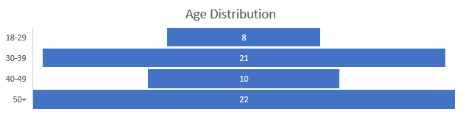

**3. OTHER CIRCUMSTANCES**

Since March 2022, 61 individuals were tested, and all tested negative. The majority of the tests

were completed at the three OP clinics. Persons served within the BHCC, and MAT programs

have the potential benefiting from HIV EIS.

**4. SUMMARY FINDINGS, RECOMMENDATIONS, AND ACTION PLAN**

Increased community awareness is a key in making this service more accessible to all individuals.

**FY22 ACTIONS TAKEN**

* Testing initiated March 2022
* HIV EIP Plan approved, with promotional material

**AREAS FOR IMPROVEMENT**

* Increase outreach activities/community education
* Create group curriculum

**COMPLETION OF ACTION PLAN FY22**

* Plan was not created since program was initiated in February 2022

**ACTION PLAN FY23**

* Increase outreach activities to 10 per month (Timeframe: 08/1/2022)
* Create group curriculum (Timeframe: 10/1/2022)
* Increase community education plan (Timeframe: 08/1/2022)

**Executive Summary**

The yearly analysis creates a framework for successfully collecting, controlling, and maintaining data as a strategic asset to support the delivery of behavioral health services, substance use disorder treatment, I/DD services, and organizational objectives. The annual analysis is driven by the concepts and values expressed in the organization's Mission, Vision, and Values. LBHS is always working to enhance the quality of the data gathered and disseminated. When necessary, LBHS guarantees that data can be easily recognized, retrieved, and accessed by individuals with a valid need to know. LBHS adheres to current HIPAA compliance standards by ensuring the privacy, confidentiality, and security of data gathered, utilized, disclosed, communicated, stored, and disposed of. Data collection and associated collecting processes is handled in an ethical, consistent, and responsible manner to guarantee data is accurate, valid, reliable, timely, relevant, and comprehensive, and is utilized for the intended purpose.

Among other secure data repositories, the key sources of data for this investigation were MyAvatar, Netsmart KPI Dashboard, ThinkHIE, ClientTrack, and external survey findings. The goal of LBHS is to collect meaningful data from all available sources for data profiling and measuring persons served level, programmatic, and organizational level data against the objectives to ensure LBHS is providing the highest quality services available while also ensuring financial viability.

The findings from comprehensive investigation across all individual programs all reverberated with the same hurdles to completing basic program functions. The most significant contributor to a program's inability to accomplish essential quality objectives is the recruitment and retention of personnel who can demonstrate expertise in their tasks. This turnover issue has a direct impact on the capacity to satisfy productivity KPI criteria and has the potential to reduce the number of persons served/provider relationship development issues required to retain persons served as returning clients.

Legacy BHS was able to maintain high levels of persons served satisfaction on most all of its programs, demonstrating all personnel's commitment to working together to achieve agency-wide goals and objectives while providing the highest quality behavioral health, substance use disorder, and intellectual/developmental disability services.

Legacy Behavioral Health Services

3120 North Oak Street Extension

Suite C

Valdosta, Georgia 31602

229-671-6109